Maqar

Yousef Byouk (23110106), Tamer Ali (23110619), Saif Ibrahim (23110247), Khaled Mudhoun (23110153)
Section Number: 1 (Yousef: Section 5)

1. Video: Entrepreneurial Mindset & Skills
Video link: https://youtube.com/shorts/ykJfDTrb0m0

2. Sector selection and exploration
Selected sector: the sharing economy and digital workspace marketplace
We chose to enter the sharing economy sector, specifically focusing on a digital workspace marketplace. This sector is built on the idea of taking underutilized assets, in our case empty meeting rooms and quiet office corners and making them available to people who need them through a secure digital platform.

Why We Chose This Sector
We chose this sector because it has a real problem that we personally experienced as students and young professionals in Amman, at the start of this semester our team spent hours searching for a meeting space to study and work, we went to multiple study houses and found them unavailable, we even called other places but they didn’t pick up and we were left with noisy places that didn’t allow us to actually focus, the main issue isn’t the lack of spaces but that there is no actual way of to find and book them.
From our point of view, the sharing economy and digital workspace marketplace is the right sector because it focuses on making better use of existing resources, which in our case, many offices, meeting rooms and workspaces in Amman stay empty for most of the day while students, freelancers and startup teams struggle to find quiet and professional spaces when they need them, which makes a clear market gap and a great opportunity for a platform to connect these two.
Also, this sector allows us to address two problems at the same time, on one hand users can gain easy access to available meeting rooms without needing to physically search for them or depend on unanswered phone calls, on the other hand office and meeting room owners can benefit from visibility, more organized bookings and extra income from underutilized spaces, which makes this model practical, effective and valuable for both bookers and providers.
And this sector is cost effective and scalable, instead of owning or renting new spaces this model would depend on utilizing spaces that already exist which reduces operation costs and makes the idea more realistic for a startup, at the same time it fits the growing need in Amman for a flexible, professional and secure workspaces.
So, in the end, we picked this sector because it has a real unmet need, connects to our own experiences and offers a practical opportunity to create value for both bookers and providers, also because we understand the problem from our experience and want to build a solution that we could use.

3. Pest analysis
This analysis examines the external micro environment affecting the proposed entrepreneurial idea which is digital platform for renting meeting rooms, connecting space providers such as café houses, study houses, companies with the users which are students, freelancers, startups, and businesses without offices.

Political factor

Overview
Jordan is considered one of the politically stable countries in the middle east, for the over past years, the government has shown increasing interest in supporting the entrepreneurship, digital transformation, and innovation ecosystems, but like many of the developing economies, there are still regulatory and structural challenges.

Opportunities
One of the most important political advantages in Jordan is the growing governmental support for the entrepreneurship and startups. The national strategies increasingly focus on the digital economy growth, innovation, and youth employment, this create a helpful environment for launching digital platforms, especially those targeting startups and freelancers.
According to the global entrepreneurship monitor (GEM) Jordan report, there has been noticeable increase in early stage entrepreneurial activity, supported by the national initiatives and ecosystem development.
The government backed initiatives such as startups funding programs and incubators have been expanding in the recent years, which benefit our idea, as we depends on entrepreneurs, freelancers, and small businesses, which are being actively encouraged in Jordan.

Threats
There are still some regulatory challenges that may effect our business.
Starting and operating a business in Jordan will involve:
- Procedures for licensing
- Taxation requirements
- Regulations for Compliance with digital platform
which might slow down the growth or increase operational costs, as the studies indicated that Jordanian entrepreneurs still face policy gaps, administrative complexity, and limited regulatory support tools, and reports from organizations such as int@j highlights the barriers like regulatory inefficiencies and lack of tailored startup polices.
Which will cause a need for legal clarity around online marketplace operations, and a contract between the owners of the meeting rooms and the users should comply with the local regulations.

Economics factor

Overview
Jordan's economy is largely based on the services and the small businesses, with a high dependence on ( small and medium enterprises). At the same time, the country face an economic pressure such as unemployment and limited income levels.

Opportunities
The structure of the economy of Jordan strongly supports our idea, at first the small and medium enterprises dominate the market, which they represent the majority of the businesses, and many cannot afford permanent office spaces. Secondly, there is a big growing number of free lancers, remote workers, and startups who require flexible, short term workspaces instead of the long term office commitments.
As the small and medium enterprises represses around 95% of all businesses in Jordan, contribute approximately 50% of GDP, and employ about 60% of the workforce, the services sector contributes roughly two to thirds of the national GDP, indication strong demand for service based solutions. Which create a clear market gap, as many businesses need meeting rooms occasionally, and many cafes and offices have unused space. Our plat form will act as a bridge between unused supply and unmet demand.

Threats
The economic challenges in Jordan cannot be ignored, as many individuals and startups operate under the tight budget, which may limit the willingness to pay for meeting spaces.
Additionally the access to funding is limited, and economic instability can reduce spending on non essential services.
The reports on Jordanian small and medium enterprise indicate that access to finance is one of the biggest challenges, limiting growth and operational spending, the high unemployment and the cost of living make a pressure affecting the purchasing power, which mean that pricing must be affordable and flexible, and the need low cost or hourly options to attract the users.

Social factors

Overview
The social trends in Jordan are always on change, especially among the young people, there is shift toward the
- Freelancing
- Entrepreneurship
- Remote work
- Flexible lifestyles
These are highly relevant to out idea

Opportunities
The target audience identified perfectly aligns with the current social trends
Which are
- Students
- Freelancers
- Startups
- Small businesses

These groups increasingly prefer, flexible working environments, collaboration spaces, and professional meeting locations without long term commitments
As the rise of the coworking spaces globally and regionally shows an increasing demand for the shared and flexible work environments, and the coworking and shared spaces are widely used by freelancers, remote workers, and startups for the networking and productivity.
In Amman specifically, many cafes already act as an informal workspaces, but they often lack private and professional meeting rooms, our platform with improve this by offering a structured bookable spaces, creating a more professional environment

Threats
There are still some social and cultural barriers, that some people in Jordan may prefer traditional offices, avoid paying for spaces when cafes are free, or be unfamiliar with the platform booking system, which create a challenge in building trust or change the user habits.

Technological factors

Overview
Technology is one of the strongest supporting factors for our idea, as the platforms depends on online booking systems, mobile applications, and digital payments, all of those are increasingly common in Jordan.
Jordan recognized for its skilled ICT workforce and strong digital capabilities, also Amman is considered and regional hub for tech talent and the outsourcing services. These allow us to build a scalable digital platform, offer a user friendly booking experience, and expand in the future beyond Jordan.

Opportunities
Technology strongly supports our idea because Maqar is based on a digital platfrom, online booking and simple digital tools jordan has a growing ICT sector, strong digital capabilites and increasing use of online services that creates a suitable enviroment for launching a room rental platform/
The strong ICT infrastructure in jordan is an important opportunity because it helps the platform operate more smoothly through cloud hosting, databases, internet services and online communication tools which means Maqar can manage room listings, bookings, user accounts and host dashboards.
The technological developement in jordan allows Maqar to provide useful features like live availability, location search, room photos, digital payments, host dashboards and booking confirmation codes which can make the booking process faster and easier for students, freelancers, startups and businesses instead of calling different places or visiting them physically to check if rooms are available.
Technology also creates an opportunity for scalability because Maqar doesn’t need to own or rent the physical rooms so the platform can start in Amman with a simple web platform then expand later to other areas in jordan as more users and space providers join also cloud hosting, databases and online payment systems can help the platform manage more listings, users and bookings with lower operational complixity.
And digital tools can help build trust between users and space providers through user accounts, host profiles, real room photos, reviews, secure payments and booking confirmation which is important because users might need confidance before booking meeting rooms online especially when the platform is still new.

Threats
There are some technological risks
Since the platform will manage users, hosts, bookings and possibly online payments, it needs secure payment systems, strong user data protection and a simple reliable user experience and if the platform is slow, confusing or not secure, users may lose trust and avoid booking through it.

Summary

Main opportunities
- Strong SME and freelancer market
- Growing entrepreneurship ecosystem
- Social shift toward flexible workspaces
- Availability of unused meeting spaces
- Strong ICT infrastructure
- Ability to use digital tools to make room booking faster, easier and more trusted

Main threats
- The complexity of licensing and regulations
- Limited purchasing power from the users
- The cultural resistance to paid of the meeting spaces
- The future competitions
- Technology maintenance and data protection needs

Final justification of the opportunity
Based on the conducted PEST analysis, our idea of the meeting room rental platform in Amman is a highly viable and justified, because:
· Theres a clear mismatch between the supply and demand as many locations have unused rooms, many users need temporary meeting spaces.
· Economics and the social conditions do support flexible and low cost solutions strongly
· The technology enable the efficient platform operation and scalability
· The political conditions are generally supportive for the startups
Therefore, the pursuing this entrepreneurial opportunity is justified as it
- Solve the real market problem
- Target to grow customer segments
- Use available technological infrastructure
- Has a potential for expansion and scalability

4. Entrepreneurship Approaches
Selected sector: Digital Sharing Economy Platform (Workspace Booking) (Maqar)
The entrepreneurship can be approached by different ways, it depends on the nature of the idea, available resources and the market conditions. Each approach bring a different way of a creating a value and solve problems.
For Maqar, there is two relevant approaches, which are Technological Entrepreneurship, and lean startup.

Approach 1: Technological Entrepreneurship
The technological entrepreneurship, focuses on creating innovative products or services using technology. Its commonly used in the digital platforms and the software based business, where the technology is the main driver of the value creation and scalability.
The key principles of the technological Entrepreneurship:
- The use of digital platforms, services and systems
- The continuous innovation and development of
- The focus on the scalability and efficiency
- The readiness adaption to technological changes
Application within our Sector
Maqar applies technological entrepreneurship by offering the digital platform which allows the users to:
- Present meeting rooms and places
- Search an available rooms in real time
- Compare the features such as price, Wi-Fi, and capacity
- Book rooms instantly online
- Filter the rooms based on place, components, and price
- List the nearest geographical meeting room
- Upload the pictures of the meeting rooms, the whole features, and the price from the provider side
This approach solves the problem of the lack of transparency and inefficiency in finding meeting places in Amman, it improves the user experience by making faster process, easier, and more reliable, also it helps the meeting rooms providers with better management, exposure, and maintenance.

Approach 2: Social Entrepreneurship
The social entrepreneurship focuses in addressing the social or community problems through the innovative solutions, the purpose is to create a positive social impact while maintaining the sustainability of the business model
The key principles:
- Solving the real societal challenges
- Creating social value and impact
- Provide accessible and inclusive solution
- The balance between profit and social responsibility
The application within the sector:
Maqar reflect social entrepreneurship by:
- Helping the students access affordable and quiet study places
- Support the freelancers and remote workers who want a professional environments
- Reduce the stress that caused by over crowded public places
The use of human centered design approach, maqar focuses on understanding the user needs, such as comfort, privacy, and affordability. Which improve the productivity and provides a better working conditions for different user groups.

Approach 3: Lean startup approach
The methodology lean startup approach focus on building the businesses efficiently, it tests the idea quickly and improve them based in the real feedback from the user.
It use the build measure learn cycle to reduce the risk and make sure that the product meets the users expectations and the market needs.
The key principles
- MVP development ( The minimum viable product)
- Continuous of testing and collect feedbacks
- The validate learning focus
- The ability to pivot or improve, depending on the results
the application within the sector
Maqar can use of the lean startup approach by:
- Develop simple prototype of the web platform
- Testing the platform with the target audience such as meeting rooms providers, students, freelancers
- Collect feedback on the usability, pricing, and the features
This allows our team to enhance the functionality of the platform gradually and make sure that it fits the real user needs before the full development. Also it reduces the risks of building a solution that doesn’t match with the selected market demand.

Comparison of the approaches
the three approaches above has difference on their focus, but all of them contribute to the development of Maqar.
Technological entrepreneurship focus on how the solution will be delivered, using the digital platforms, which will cause in improving the efficiency and scalability.
The social entrepreneurship focus on the reason of the solution importunity, by addressing the user needs and improve the access to the suitable works[aces
Lean startup focuses on how will the business is developed, ensuring that the idea will be tested, validated, and improved through the user feedback.
These approaches provide the difference between perspectives on how will maqar be developed and implemented. While the technological entrepreneurship will enables the platforms functionality, the social entrepreneurship make sure of the user value, and the lean startup approach will support the efficient development and validation, the most suitable approach will be selected and justified.

5. SWOT Analysis

Internal strengths:
There are a few strengths that would allow us to build a high quality product without any extra help during our first phases:
- Technical mix: our team consists of two computer science students and two cybersecurity students which allows us to build a secure inhouse platform.
- Advanced prototyping and technical skills: we have strong internal skills for prototyping and technical execution which allows us to build the MVP for a low cost (or zero cost)
- Social connections: our team has valuable connections within Amman which helps us reach potential partners, and gain early support and list our first host locations more effectively.
- Leadership and team work: we are able to make decisions, divide the work and continue working under pressure, these qualities are important for handling challenges, meeting deadlines and keeping the project moving on plan.
- Target audience perspective: as students, we are part of the target market because we have faced the difficulty of finding quiet, professional and available workspaces in Amman, so we have a good understanding of the need which is why we can build a solution that matches it.

Internal weaknesses:
Even though our team has strong capabilities, we also have a fair amount of weaknesses that could affect the project:
- limited experience and market knowledge: as students, we have limited professional experience and we don’t have deep knowledge of the market and workspace rental which will make it difficult to approach hosts and understand the market fully at the start.
- Limited funding: we currently don’t have any funding to support development, marketing or operations which will limit how much we can do in the short term.
- Time limitation: as students we work under academic deadlines, so our available time is limited and that adds pressure on development and testing.
- Varying skill levels: we don’t have a unified understanding of all required technical knowledge.
- Limited business experience: we lack experience in areas like negotiation, sales and business development which are required to scale the platform.

Opportunities:
There are some opportunities that can help our business grow:
- SME dominated market: most businesses in Jordan are small and medium (around 95%) and most can’t afford expensive meeting rooms so they do rent meeting rooms hourly.
- Government support: the Jordanian government supports startups and young people who want to build business and that gives us a chance to get funded.
- Remote work: many workers in Amman now work from home or freelance, but they still need a good place to meet or work sometimes.

Threats:
- Trust barrier: many office owners might hesitate to allow strangers into their workspace because of security concerns and possible damage.
- Regulatory and licensing complexity: starting and operating a digital platform in Jordan could have legal, administrative, licensing and taxation challenges which could slow down implementation.
- Limited purchasing power: high unemployment and rising living costs could reduce how much students, freelancers and startups are willing or able to spend on workspaces per hour.
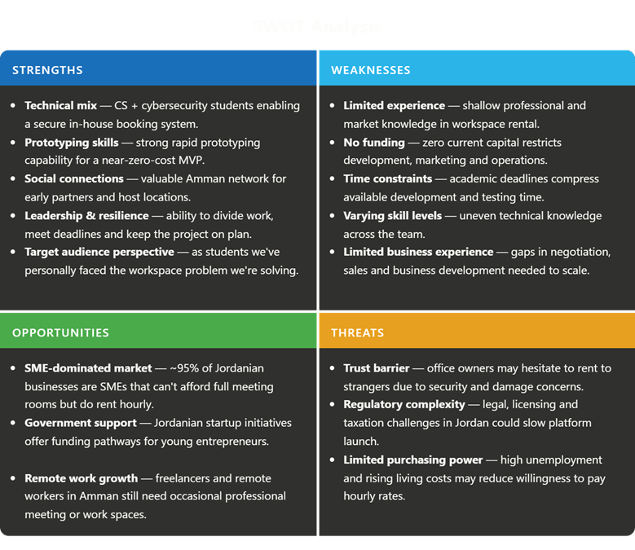

6. Selected entrepreneurship approach:
Hybrid approach (technology entrepreneurship and lean startup)

Justification:

Sector conditions:
Maqar’s best fit is a hybrid approach because it is a digital marketplace that uses technology to solve a clear market problem, the platform allows users to find and rent professional meeting rooms online, compare options (based on location, capacity, pricing and availability) and book instantly using a user-friendly interface, also it helps room owners list underutilized spaces, manage schedules and generate extra income. This makes the project align well with technology entrepreneurship since the business depends on a digital platform, secure systems and scalable operations, also the market includes strong demand from freelancers, students and startups that need flexible and affordable spaces but it comes with some challenges like trust concerns, licensing complexity and price sensitivity which is why lean startup is also important because it allows us to start with an MVP, validate our assumptions during early stages, reduce risk and improve gradually using feedback and user behavior.

Team skills and capabilities:
Our team includes two computer science students and two cyber security students which gives us the ability to build the platform in house and develop the core features securely like the booking and user verification process and this does greatly support technology entrepreneurship side of the project because the business depends on technical implementation and functionality, on the other hand it also supports lean startup because we can develop a prototype at low cost, ensure that the core essential features are working and improve the platform through quick iterations.

Future direction:
The hybrid approach also supports the future direction of Maqar, after validating the concept in Amman, the platform can expand to other cities in Jordan and could reach regional markets later, it also supports scalability since the platform can grow by adding more features like subscriptions, paid priority listing for hosts, ratings and reviews, favorite locations and catering options, these future additions can be added gradually based on user feedback and demand which supports lean startup but the platform stays as a scalable digital solution which supports technology entrepreneurship approach.
The hybrid approach is the most suitable for Maqar because it reflects the natures of the business and how we will develop it, as it is a technology based solution that depends on functionality, secure systems and scalability while requiring a lean approach to test concepts early, reduce risk and improve the platform gradually based on feedback.
Although hybrid approach is highly supported and suitable for Maqar, but there are some worries that it has some limitations. Building a technology based platforms will require continuous technical maintenance, the cybersecurity protections and updates increases the costs over time, also the lean startup depends on the testing and feedback, but the early user adoption may be slow, because the trust online room booking still under development in Jordan, the business may also face legal and operations challenges, such as provider onboarding, service consistency and licensing requirements. However, despite these limitations, the hybrid approach remains the most, for allowing Maqar to start small, reduce risk and improve. While building a scalable digital platform.

7. Problem Identification and user research

The initial problem (what we first thought)
Students, freelancers and remote workers in Amman struggle to find available places to sit and work in cafes which wastes time and reduces productivity.

When we started thinking, we had a simple idea: It is hard for people to find a place to sit in cafes because they are always full. We thought that just creating an app to see if a table is free would solve the issue. However, we realized this was a very shallow view of the real struggle people face in Amman.

Our research methods (how we gathered the facts)
To prove there was a deeper problem, we used three specific research methods with our stakeholders:

Quantitative research (surveys):
We created a survey and shared it within the HTU student community and local freelance groups. We have received an 132 responses.
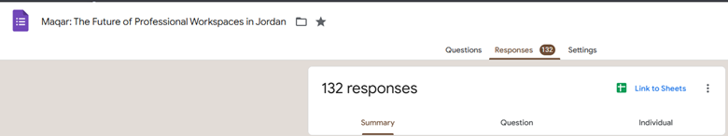
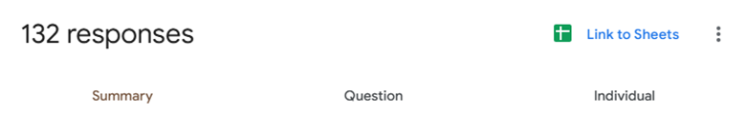
To ensure our research captured a wide and accurate range of perspectives , we used a multichannel approach to distribute our survey . We shared the link across the university groups and on our personal social media accounts, which helped us reach a large audience of students, and freelancers who deal with these workspace issues daily . Also, we took a more targeted approach by sending the survey directly to several local business owners that we know and office managers to gather their specific insights as potential hosts.
This combined effort was highly effective, allowing us to collect a total of 132 responses that reflect the real-world needs of both the people looking for space and the businesses providing it.

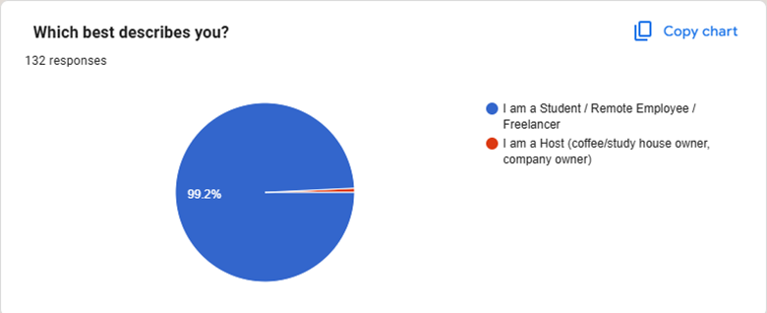
Out of 132 total responses the data shows a very clear picture of our primary audience. About 99.2% of our respondents identified as students, remote employees or freelancers while less than 1% identified as space hosts (coffee shop or company owner).
What this tells us: this validates that our core demand side, the individuals struggling to find quiet and professional workspaces, is strong. These are the people who face the same pains our team experienced which is the pain of looking for a reliable place to do an important interview or get serious work done only to face uncertainty about availability or noise levels.
Refining our approach: Because our survey was mainly by the users not hosts, we have confirmed that the market demand for a platform like Maqar exists heavily in amman. However this imbalance provides a action for our next phase:
while we have validated the user need we need to shift our future research and outreach efforts specifically the host side. Our next step is to conduct interviews with office managers, local startups and property owners to understand their side. specifically, what would make them feel comfortable and secure enough to rent out their underutilized meeting spaces to the professionals identified in this survey.

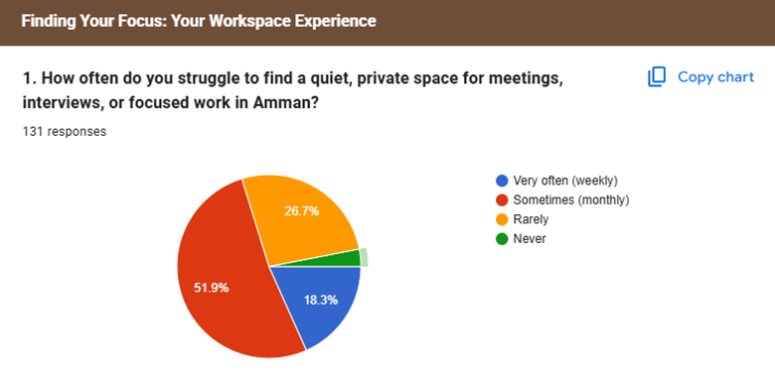
A combined 70.2% of respondents experience this struggle on a regular basis with 18.3% facing it weekly and 51.9% facing it at least once a month. Only a small part of participants (about 3%) said they never had this problem.
This confirms that the search for space is not a rare, it is a point of pain in the professional lives of our target users. The fact that over 70% of people deal with this monthly or more frequently suggests that the current options in Amman such as traditional cafes or study houses are not solving the need for reliable, private and professional working environments.

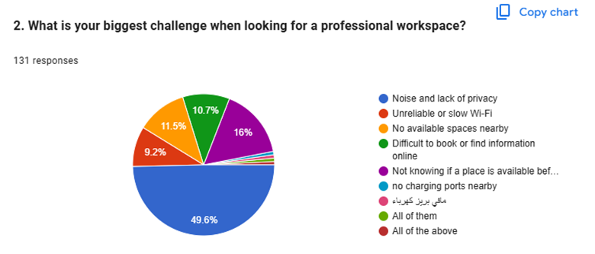
The data provides a clear list of frustration and their importance. Nearly half of our respondents (49.6%) said noise and lack of privacy as their single biggest challenge. This followed by uncertainty about availability (16%), a lack of available spaces nearby (11.5%) and difficulties with the booking or information seeking process (10.7%). Unreliable Wifi and power accessibility also was notable.
This validates that our users are not just looking for a desk they are looking for reliability and control.
The privacy gap: The dominant 49.6% finding confirms that current workfriendly environments (like cafes) are failing our users. They need more than just a chair; they need a controlled environment where they can speak freely and think deeply.
The information Void:When we combine the frustration of "not knowing if a place is available" (16%) and "difficulty booking/finding info online" (10.7%), over 26% of the pain points are purely logistical. Users are wasting time and energy just trying to figure out if a space is usable.

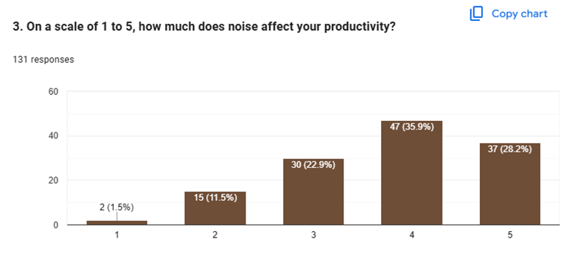
The results of this question provide a very clear signal about why our users are struggling. When we asked participants to rate how much noise hinders their work, an majority 64.1% of all respondents chose a 4 or a 5. This indicates that for nearly two thirds of the people we surveyed, noise is not just a minor annoyance, it is a barrier that destroys their ability to focus and get things done.
It is also important to notice that only a small percentage of our audience, (less than 2%) felt that noise was not a problem at all. This data is a validation of our core mission with Maqar. We are not just building a booking platform, we are trying to solve a huge productivity problem. By offering private and quiet meeting spaces we are addressing the biggest factor that our users say prevents them from doing their best work. This confirms that the demand for our service is driven by a real need for a place where professionals can escape the noise and finally find their focus.
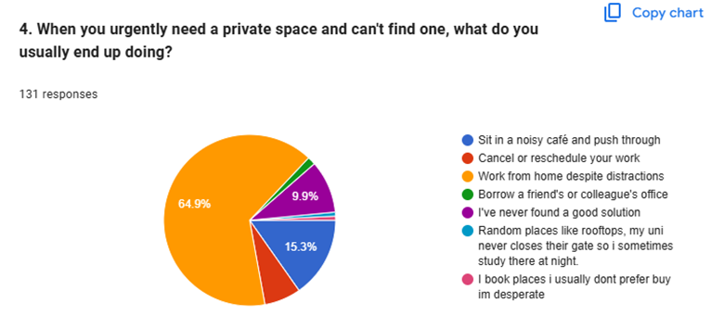
The results of this question highlight exactly why our target users are frustrated. When faced with a lack of private space, over 80% of our respondents are forced to settle for less optimal environments. The majority (64.9%) ended up working from home, despite the distractions that come with it , and another 15.3% have to head to noisy cafes and push through the chaos. most concerning is that nearly 10% of our participants admitted they have never actually found a good solution for this problem.

This data tells us: professionals in Amman are currently in a mindset where they have no perfect solutions for their problems. They aren't choosing home or cafes because these are the best places to work, they are choosing them because they have no other options. This validates the need for Maqar. We aren't just trying to provide a space, we are trying to provide a better solution to the cycle of compromising on productivity .By creating a platform that connects users to reliable, private meeting spaces, we are giving them a way to stop settling and finally work in an environment that actually supports their focus and professional needs.

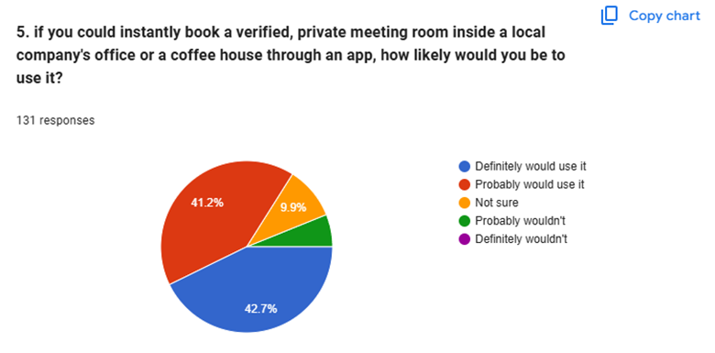
This is the most important finding in our survey because it is an indicator that tells us how many people are willing to instantly use our platform once it is up and running and has all the features we gained from all the insight methods we did. When we asked our potential users if they would actually use a platform like Maqar, the response was a huge "yes." A combined 83.9% of respondents stated that they would either "definitely" or "probably" use our service. To see such a high level of interest where more than 8 out of 10 people expressed clear interest to adopt our solution are strong indicator of market opportunity.
This data validates our entire project vision. We are no longer just guessing that people want a better way to work, we have proof that the demand exists and is waiting to be met. The very small percentage of users who were unsure or unlikely to use the service suggests that our target audience is well aligned with the problem we are solving. so this question confirms that if we build a reliable, easy to use platform, the users are already there and ready to sign up.
Moving forward this gives us the confidence to shift from problem validation to solution development. We know exactly who needs this, why they need it and most importantly that they are eager for a tool like Maqar to help them.
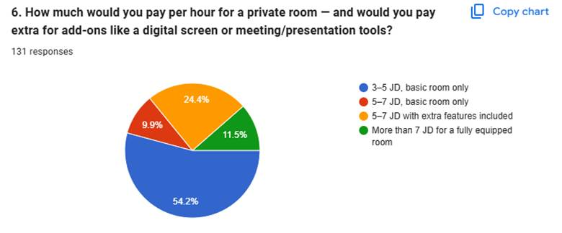
The data from this question gives us a very clear plan of our pricing strategy. The majority of our respondents (54.2%) are looking for an affordable, accessible price point in the (3 to 5 ) JD range for a basic room. This confirms that for our primary audience students and freelancers value for money is the most important factor in their decision making process. They want a space that is functional, but they don't want to overpay for luxuries they don't need.
Because we cannot change the pricing of the current rooms and this is a process that is mainly the host responsibility and preference, instead of changing the prices and working towards a very difficult goal, we should aim to have the first phase of hosts on our platform to be in that price range, then we can expand to other price ranges.
However, the data also reveals an important opportunity for upselling. About ( 36% ) of our participants (combining the 24.4% and 11.5% segments) are willing to pay a premium 5 JD or more, if that price includes extra features like screens, projectors or other professional tools.
This suggests a tiered pricing model would work best for Maqar. By keeping a base price of (3 to 5 ) JD, we can capture the mass market, while also offering premium packages that include technology and presentation tools. This allows us to accommodate the budget conscious user while also capturing the higher paying customers who need a fully equipped, professional environment for important meetings.

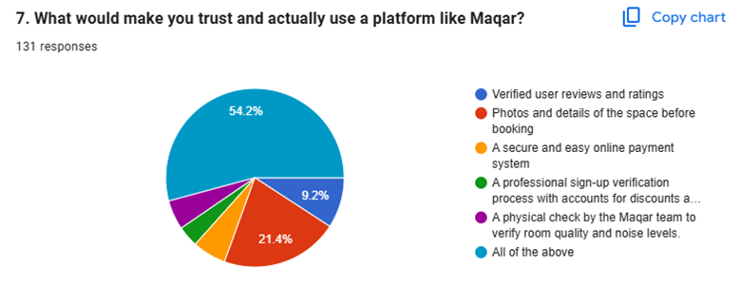
The results of this final survey question are very clear. When it comes to trusting a new service, our users don’t want to choose between features, instead they want the full package. A massive (54.2%) of our respondents selected “ All of the above” signaling that for Maqar to succeed, we cannot rely on just one security measure or feature, Our users are looking for a complete system of trust that includes verified reviews, transparent photography, secure payment systems and active quality assurance.
This data is a validation for our team. It confirms that trust is not a single feature we can just build and forget it is the entire foundation of our platform. Users want to know that they are paying for a space that is exactly as advertised, that their payments are safe and that the quality of the space has been checked.
For us, this is an important insight as we are building Maqar as a security first approach, based on our own technical background we are able to deliver exactly what these users are asking for, and we will do it by integrating verifications, secure booking engines and review systems.

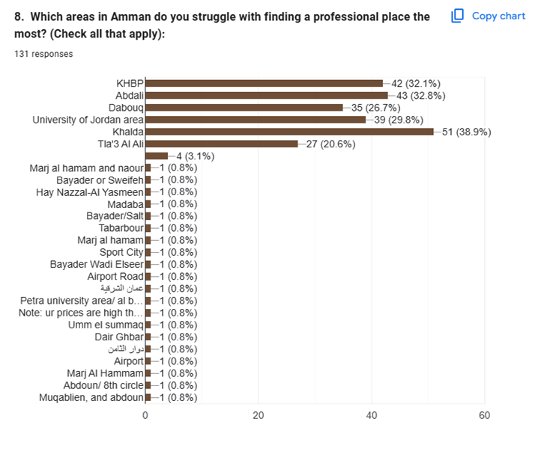
The data reveals that the workspace crisis in Amman is not spread evenly across the city. However it is concentrated in specific business, academic and residential hubs. The survey highlights five primary pain zones where the majority of our users are struggling: Khalda (38.9%), Abdali (32.8%), the King Hussein Business Park (32.1%), the University of Jordan area (29.8%), and Dabouq (26.7%). While there is a long tail of other areas mentioned, these five districts clearly represent the centers of the problem.
This shapes how we will plan our launch strategy, that we do not need to attempt a city wide launch all at once. Instead this gives us a clear priority list, by focusing on our initial marketing, host recruitment and partnerships focusing on these top five, we can maximize our impact where the demand is already proven to be highest. If we successfully solve the problem in these places, we will satisfy the largest portion of our user base and establish a strong localized reputation before expanding into the entire city of Amman.

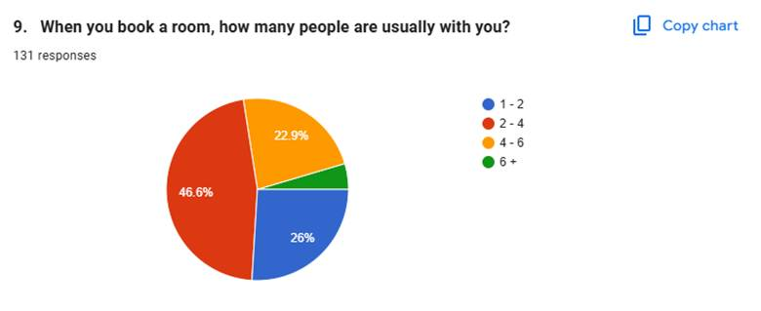
The data from this question provides a clear picture of what kind of physical spaces our users actually need and want . A significant majority (72.6%) of all respondents typically book rooms for groups of (1 to 4) people. When we include the groups of (4 to 6) people (22.9%), it becomes very clear that the demand is focused on small to medium sized rooms. Very few people are looking for large scale event spaces or massive conference halls.
This is a critical insight for our business model and our host recruitment strategy, It tells us that we don't need to go for large, empty auditoriums to make Maqar successful. Instead we can focus our efforts on finding and listing small meeting corners, and private study areas that are already common in many office layouts. This is a huge advantage because these smaller spaces are much easier for hosts to make available and much cheaper for our users to book. By focusing our platform on these smaller, high demand capacities we can ensure that our inventory perfectly matches what the market is actually looking for keeping our operations efficient and our booking process simple

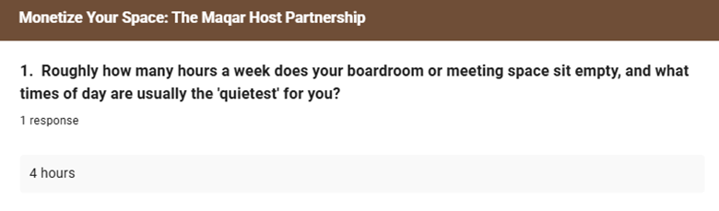
Analysis of the Host: Early Insights into Unused Capacity
The feedback we received from our host survey provides a very encouraging starting point for the supply side of our project. Even with a limited initial response, hearing that a professional space sits empty for at least four hours a week is a significant data. It confirms our fundamental business concept: that there is dead time in the professional world where valuable meeting spaces are sitting idle. For a business owner those four hours represent a lost opportunity to generate revenue, especially when those offices still require rent and ongoing maintenance costs to exist.
This initial insight helps us paint a clearer picture of the supply side of our marketplace. It shows that Maqar is not just a convenience for users, it acts as an asset optimization tool for the hosts. By allowing these companies to monetize their empty boardrooms, while offering them simple low effort way to help offset their monthly costs. It validates our Win Win vision in our project, hosts gain extra income and free marketing exposure, while the user finally gets the professional environment that they have been searching for .
we recognize that gathering research from business owners has been a different challenge than surveying the students and freelancers. Because of their limited time, the plan is to go from broad public surveys to a more focused personal outreach. The next step in our project is to have direct conversations with the office managers and the company owners for better understanding of the specific operational and the security concerns which may make them comfortable listing their space through our platform.

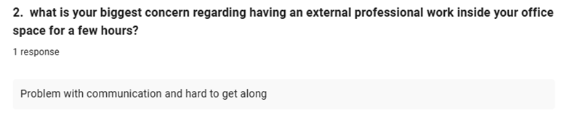
This feedback provides a look at the host side . While many of them might assume that the office owner’s biggest concern would be physical security or hardware manipulation, this respondent highlights a more subtle but just as important issue: the social compatibility of the person coming into its workspace. They are essentially worried about a guest being difficult to communicate with or disrupting the daily flow of their current office team. This is a very real, non technical problem that we need to solve if we want businesses to feel comfortable and relaxed about opening their doors to strangers.
This insight is actually perfect for the security first approach, but it will force us to expand our definition of what security means. For Maqar, building a secure platform means not just verifying their government ID, but it means building a good reputation.

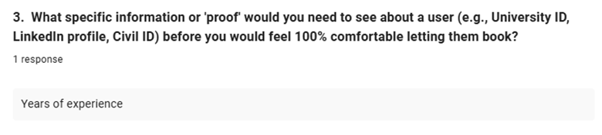
When the host suggests that years of experience is what they need to feel comfortable, they tell us that they want to know they are hosting a serious, established professional rather than just a random individual. This helps us define the culture of Maqar community. It suggests that the platform can't just be a place to book a desk, but a space for serious people to get serious work done
For a possible future plan in developing the platform, We can integrate a professional profile section into our user onboarding process where guests can highlight their career stage, field of work or years of experience. Just like a professional networking site, having a clear professional summary visible to the host can serve as a powerful trust builder.
This requirement also fits perfectly with our security first vision. While we will handle the technical side of identity verification in the background, adding these professional markers allows the host to make an informed decision about who is entering their office. It gives them the assurance that their space is being used by someone who shares their commitment to professional standards. By making this information a visible part of the booking experience, we help foster a workspace environment built on mutual respect and professional compatibility.

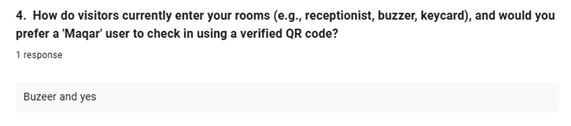
This host currently relies on a buzzer system, which is a very common but often inefficient way to manage the office entry, it requires a staff member to interrupt and buzz them in, this disrupts the daily office operations and can also create a security gap since the person buzzing the guest in might not always know exactly who is entering or if they have the access to be there, it’s a process that can be easily avoided with better technology.
The host’s acceptance for a verified QR code check in system is a huge win for our project, it shows that business owners are ready and willing to move away from outdated manual processes and use more efficient digital solutions. The implementation of the QR code system gives us the ability to fully automate the entry process, and it creates a secure, trackable and contactless method for the guests to verify their booking and enter the building, which will keep the office more secure with removing the need for consistent interruptions, allowing the host’s team to focus on their work without any distraction.
By modernizing the entry process, we aren't just making life more convenient for the host, we are making the entire workspace ecosystem safer and more professional. This response reflect as a green light to focus on building a seamless digital (handshake) between our platform and the host’s office, and it tarns the old school buzzer problem into a smarter, secure, and modern experience for our users.

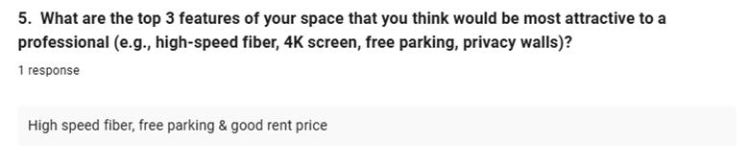
Analysis of the Host Perspective: Essential Amenities and Value
This feedback highlights the essential "must haves" that define a high-quality, professional workspace. When a host prioritizes high-speed fiber, free parking, and fair pricing, they are showing that they truly understand the practical, day by day needs of a professional. In a city like Amman, where reliable internet and parking availability are frequent sources of stress, these features are not just extras they are the core factors that will make a listing on Maqar stand out. It is a very grounded perspective that suggests the most attractive spaces aren't necessarily the most luxurious, but the ones that solve the most basic problems for a user.
For our platform development, this is a clear signal that we need to build strong filtering and tagging features. We shouldn’t just list a room as "available"; we should allow hosts to prominently highlight these specific amenities directly on their profile. If a user can quickly filter for spaces that guarantee high-speed internet and hassle-free parking, we remove the guesswork and help them find exactly what they need in seconds. It simplifies the decision-making process for the user and makes Maqar a much more attractive and efficient tool for professionals who value their time.
Lastly, this response reinforces the economic side of our project. By including "good rent price" as a key feature, the host is acknowledging that our platform succeeds when it creates clear value for both sides. It is a reminder that we are building a two-sided marketplace where transparency in pricing and reliability in amenities are key to building long-term trust. This input serves as a perfect blueprint for how we should structure our listing pages to ensure they are as helpful and informative as possible for our community, ultimately making it easier for hosts to find renters and for professionals to find the perfect space.

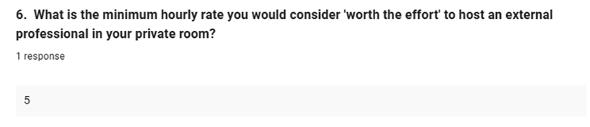
The response of 5 JD as a minimum hourly rate is a very useful data point for our business planning. It gives us a clear understanding of the break even point for a host, the moment where the income becomes worth the administrative effort of coordinating a guest booking. Knowing this helps us structure our future revenue model to ensure it is attractive enough to encourage hosts to keep their rooms available on the platform, while still remaining competitive in the wider market.
this price point reminds us that our technology needs to keep the process efficient. If the host feels that 5 JD is the worth it threshold, our app must ensure that the booking, verification and check in processes happen with as little manual intervention as possible. By keeping our platform's operations smooth and automated, we help ensure that the host's time is spent running their business, not managing bookings.

Qualitative research (interviews):
We conducted short, one on one interviews with three small startup owners.
Analysis of the Almond & Wizdow:
To get a real world perspective on how Maqar can help businesses, we met with the managers at Almond and Wizdow to discuss their current workspace management. We wanted to know exactly what happens behind the scenes and what they need from a platform like ours. The results were incredibly clear: the current manual way of doing things is creating a lot of unnecessary stress. Both managers explained that relying on phone calls and WhatsApp messages is fine during quiet times, but it becomes a nightmare during rush hours. Baristas are often too busy making coffee to pick up the phone, leading to missed bookings or forgotten details. They admitted that both the staff and the customers often forget to send or confirm booking information, which makes the whole process feel disorganized and unprofessional.
One of the biggest issues we analyzed from these interviews is the no show problem. Right now, if a customer cancels at the last minute or just doesn't show up, the manager has to manually call around to try and fill the room, or worse, just let it sit empty and lose money. Both Almond and Wizdow were very interested in our down-payment feature and the automated notification system. They told us that having a system where customers commit financially and get reminders would solve their biggest headache. They also felt that our website carries no financial risk for them, making them even more eager to join the platform. It was great to see that they aren't just looking for a simple calendar, they want a professional partner that helps them maximize their profit without adding extra work for their busy staff.
These interviews also helped us make some very smart changes to our security features. While we initially thought about requiring physical IDs, the managers mentioned that they don’t usually ask for IDs anyway. Instead, they were much more excited about using a secure QR code system for check-ins. This led us to a change: instead of forcing users to upload IDs, we will focus on building high-quality user profiles and using QR codes for extra security at every step as a future plan. This makes the process much friendlier for the user while still giving the host the peace of mind they need. They also loved the location feature, as it helps people find the nearest room instantly. Almond is even planning to expand their meeting room section, and they suggested putting our QR codes directly in the café so people can check availability on the spot. This feedback proves that there is a huge demand for a digital, automated system that takes the weight off the managers' shoulders and lets them focus on growing their business.
Observational research: Our team visited four different study houses in Amman. We sat there for half hour each time to observe the environment and the behavior of the people working there.

The evolution of the problem: from initial ideas to real world insights
When we first started Maqar, our initial problem statement was simple and limited in scope, we believe that the problem was that people in Amman struggled to find a place to sit in cafes because they weren’t easy to get to and view their information unless you went there physically, during that stage we thought a basic app that shows if a table was available would be enough to solve this issue but this surface level assumptions didn’t reflect the actual deeper challenges that both users and providers faced.
After conducting our research we realized that the problem isn’t just about availability. Through our survey (132 response from students, freelancers and small number of potential hosts we also interviewed) we found out that the quality and reliability of the workspace itself, most of the responses had an issue with noise and lack of privacy mainly and some other problems like availability, difficulty finding valid information and unreliable services, this showed us that users were not just looking for an empty seat, but for a quiet, private and professional workspace where they could focus and work effectively.
Also through interviews with managers at Almond and Wizdow we found out that hosts were facing some operational problems like that their current systems rely on phone calls, whatsapp messages and manual scheduling which could lead to missed bookings, forgotten details and bad communications, which changed our understanding of this issue the problem wasn’t only that users couldn’t find suitable spaces but also that businesses with available spaces didn’t have an easy system to schedule and manage these spaces.
Based on this feedback, our refined problem statement became that:
“Students, freelancers and remote workers in Amman struggle to find reliable, quiet, private and professional workspaces that cover their professional needs, while businesses with underutilized meeting rooms lack an efficient and trustworthy way to manage bookings, leading to wasted time, lost productivity and missed extra revenue.”

8. Target market and user persona

8.1: Define your target market segment:

Bookers (demand side)
Our target demand segment consists of users in Amman who need access to quiet, private and professional workspaces on a flexible basis, which includes university students like HTU and JU students especially during finals, capstone projects, exams and interviews, also freelancers, remote workers and small startup teams. These users usually struggle to find suitable spaces through traditional options like cafes or study houses where noise, lack of privacy, uncertain availability and limited transparency reduce the quality of their experience, so many of them visit locations in person or rely on phone calls that might not be answered and this wastes time and creates uncertainty. As a result, this segment is strongly attracted to solutions that offer convenience, reliability and clear information before arrival. Maqar is well aligned with this market because it addresses their need for professional spaces that can be discovered, compared and booked.

Providers (supply side)
Our target supply segment consists of businesses and venues in Amman that have underutilized professional spaces and could benefit from making them more visible and easier to book, one important part of this segment is offices and companies in commercial areas such as KHBP, Khalda, Abdali, and Dabouq. These businesses often have meeting rooms, boardrooms, or extra office spaces that remain unused for part of the day, even though they still are a fixed operational cost, so by listing these spaces on Maqar, they can improve space utilization and generate additional income.
Another important part of the supply segment is coffee shops and study houses, these providers already attract students and freelancers, but they often rely on informal booking methods or limited visibility which means potential bookings can be missed, so for this group Maqar offers a way to make room availability clearer, simplify booking and reach more users who need reliable workspaces. In both cases, Maqar helps providers turn idle or poorly managed space into a more productive and accessible asset.

8.2: user persona
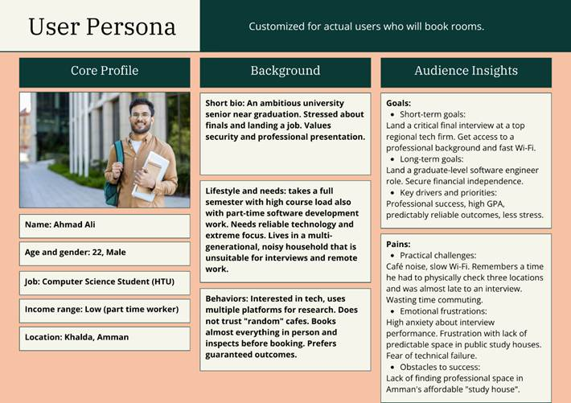
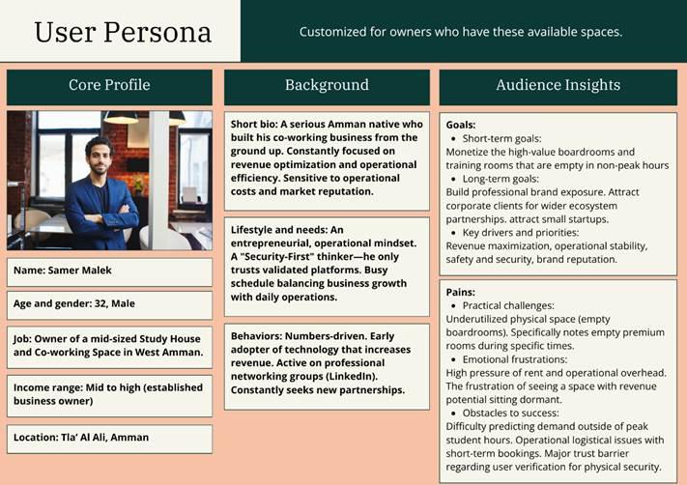

9. Business solution:
Maqar is a digital marketplace designed to transform the way professional meeting rooms are discovered and booked in Jordan, this solution was inspired by Airbnb. The platform connects individuals, freelancers, students, startups and organizations that needs temporary workspaces with providers who have underutilized meeting rooms, offices or boardrooms available for rent per hour.
Using a simple user friendly interface, bookers can browse available rooms online, compare options based on location, capacity, pricing and availability, then book instantly without needing to physically be there or wait on the phone for someone to pick up.
On the other hand, room owners can list their spaces, manage their schedules efficiently and generate additional revenue from unused rooms.

How does it address the problem:
Maqar directly addresses the identified problem of difficulty finding professional quiet and available meeting spaces in Jordan, because many startups and students waste time on visiting multiple locations or making phone calls just to check room availability, pricing or suitability.
The platform addresses this problem by letting users search and compare meeting rooms online based on their criteria (location, capacity, price and available time slots), which saves time, reduces stress and allows instant bookings without unnecessary delays.
Maqar also addresses the underutilization of office spaces. Many companies pay high rent for meeting rooms that remain empty for long periods. So, by allowing these businesses to list their unused rooms for hourly rental, the platform helps them generate some extra income easily.
And most importantly Maqar improves trust and convenience though secure bookings, verified users and clear room information, creating a more efficient and reliable workspace solution for Jordan’s professional community.

Value proposition:
The value proposition was developed for Maqar to show how the platform address customer needs and creates value for both users and hosts. It connects the main customer pains and gains with features and benefits offered by the platform

Bookers canvas:
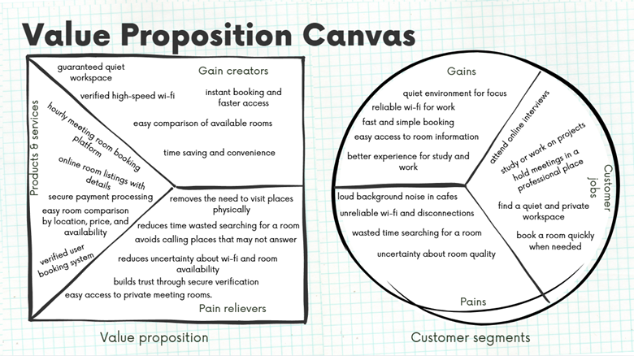
This canvas shows how the gains identified are supported by Maqar gain creators. For example, the gain of having a quiet environment for focus and that is matched by the gain creator of guaranteed quiet workspace, the gain of reliable wi-fi for work is addressed by verified high-speed wi-fi, the gain of fast and simple booking is supported by instant booking and faster access, the gain of easy access to room information is linked to easy comparison of available rooms, and lastly the gain of a better experience for study and work is supported by time saving and convenience.
Also shows how pains are handled by the pain relievers. For example, Loud background noise in cafes is reduced by easy access to private meeting rooms, unreliable wi-fi and disconnections are addressed by reducing uncertainty about wi-fi, wasted time searching for a room is addressed by removing the need to visit places physically and by reducing time wasted searching, the pain of having to contact multiple places is reduced by avoiding calls to locations that may not answer, lastly uncertainty about room quality and trust is addressed by the secure verification system, which helps users feel more confident in the platform.

Provider canvas:
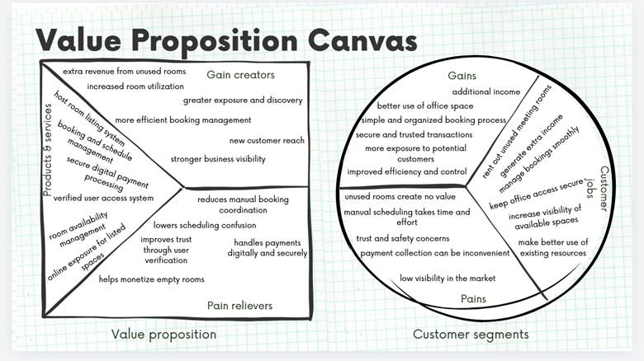
The providers canvas shows how the gains expected are met by the gain creators for Maqar. For example, For example, the gain of additional income is supported by extra revenue from unused rooms, the gain of better use of office space is supported by increased room utilization, the gain of a simple and organized booking process is addressed by more efficient booking management, and more exposure to potential customers is supported by greater exposure and discovery and stronger business visibility, lastly the gain of improved efficiency and control is reinforced through new customer reach and better booking organization.
The providers pains are also addressed by Maqar’s pain relievers. For example, The pain that unused rooms create no value is relieved by helping monetize empty rooms, manual scheduling that takes time and effort is reduced through less manual booking coordination and lower scheduling confusion, trust and safety concerns are addressed by improving trust through user verification, inconvenient payment collection is solved by handling payments digitally and securely, lastly the problem of low visibility in the market is reduced by the Maqar’s listing and exposure features, which help providers reach more customers online.

Prototype and testing plan

10.1 and 10.2: Present your initial prototype and explain key features and user benefits:
Starting at the home page (landing page), all users are met with a map of the available meeting/private rooms near to their location. This is an interactive map that shows these rooms and syncs with the selected filters, and users can zoom in or out for more freedom of view and ease of control.
Another part of this screen is at the top of the map, where there is an option to continue as hosts (room providers), or as users (who will book), and once an option of these 2 is selected, the user can then have the freedom to go to their personalized dashboard.
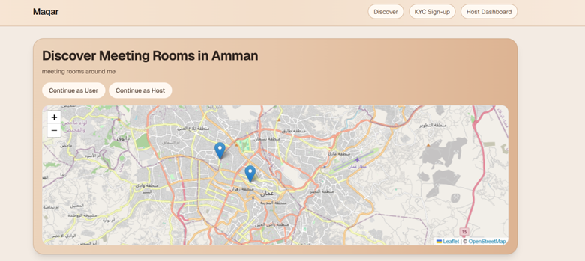
Under the map in the main screen, there are room options that act as features and options that different rooms have to offer, and a capacity filter that is useful for finding the perfect room for the number of team members. Another option that is built around the comfort and ease of use of the user, is the sorting option where users can select from a drop list to show the results of the selected sorting method first.
Scrolling further down on the home screen, users can view listed rooms, with a big preview picture of the available room, other than the room preview, users can view the title of the room, as well as the location, capacity, price, top features (features that make this place unique). And finally, there are 2 options, either click on the room to view its full details, or go straight to the booking.

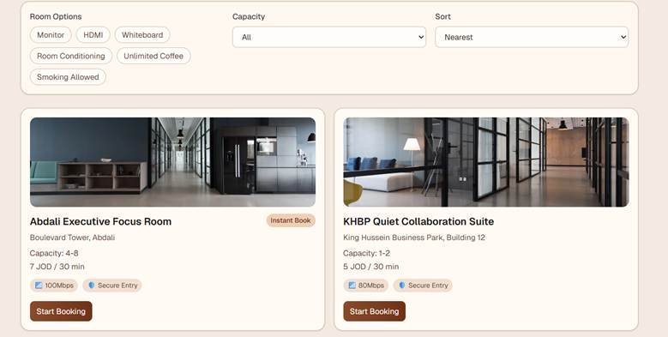

Once a user clicks on a room, they can view all images available, more features (not only unique ones), the pricing and booking policy of Maqar, and the policy of the host that provided the room. And they cant book unless they agree to their policies. There is also a tag for verified businesses.
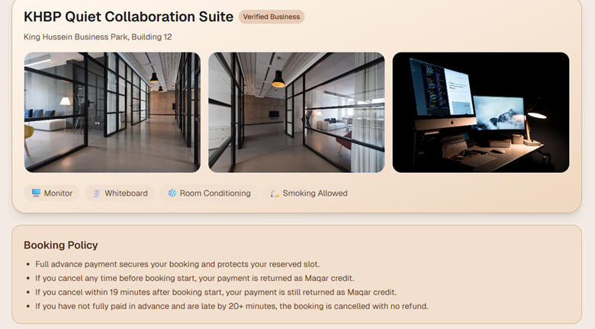

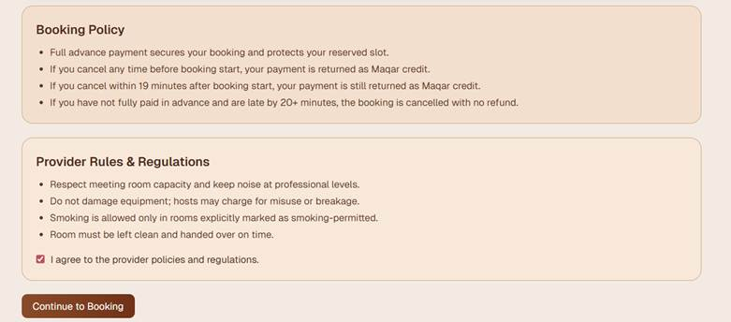

The user can then click on booking the room, then are redirected to the booking and payment page. In this page, users can select the starting time and the wanted duration based on availability. And it will show them the payment details, and tell them to submit proof of payment, that will then allow them to confirm booking after attaching the proof, and will send the booking request to the host to then confirm or deny their request.
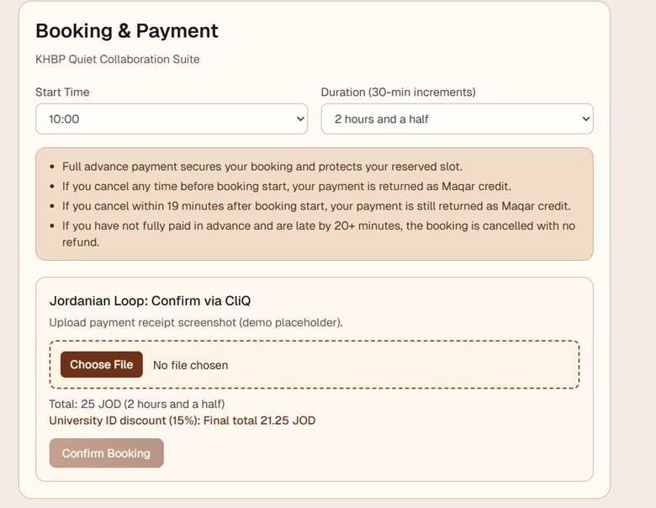
After they confirm the payment they will receive a unique QR code that will need to show to the host once they visit the room, this is to add more security. And then there is the option to go to the bookings dashboard.
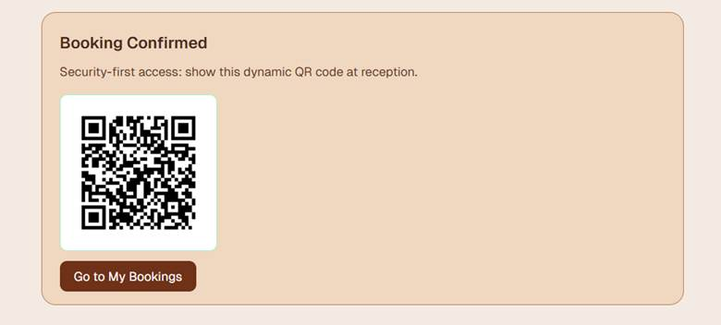
In the login page, users need to create an account with some sort of guarantee or responsibility in case of any damage or other issues in the meetings rooms. The current options are to upload a civil ID, or a student ID. If a user registered with the student ID, they can be eligible to student discounts. And this proof of personality is required to continue on with the booking and payment.
We are currently studying the option to go with an account creation with an email and phone number instead of IDs as this will be more easy for users and more privacy protected, and we will possibly go with this change in the future.
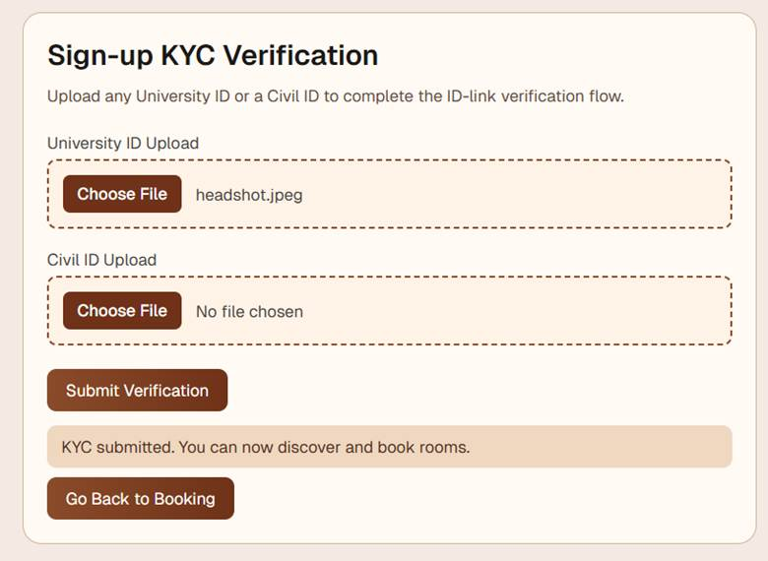

Finally in the user dashboard, users can view their bookings and how much time is left to that booking, and there is an option to notify the host that they will be late or to cancel the booking.
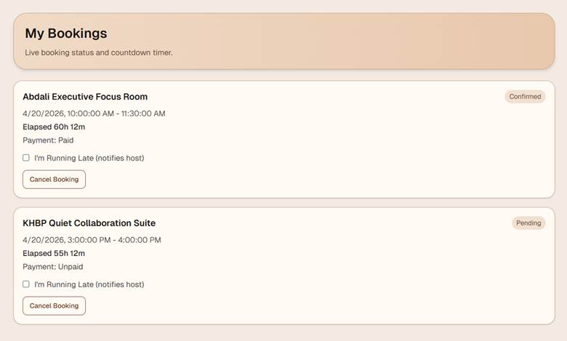

As for the host dashboard, they can view their revenue for the day, their number of confirmed and approved bookings, and the occupancy percentage. As well as show the occupancy calendar as a chain.
They can also view notifications from the users that they will be late to the meeting.
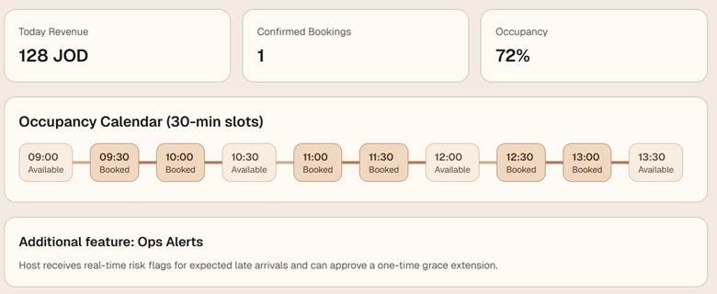

Hosts also have the option to manage the bookings and list new rooms.
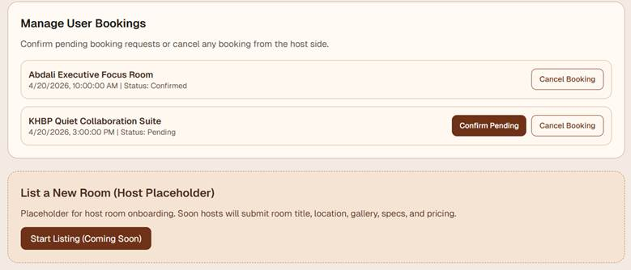

User Benefits:
The Maqar prototype is tailored and customized to make the stressful manual search into a streamlined high trust process. The Interactive map view directly addresses the pain of wasted time and transparency gaps in Amman by allowing users to visualize available rooms near their current location that also works for selected filters, so we eliminate the need for physical visits and frustrating phone calls that hosts might not have the time to answer the phones during rush hours. This is further enhanced by our filters which act as powerful gain creators. These allow a users to specifically look for a quiet room with a monitor for a high stakes interview or a startup team to find a whiteboard equipped space for a sprint ensuring that the environment perfectly matches the professional job at hand.
The QR Code and ID verification systems provide a level of security and peace of mind that traditional cafes cannot offer. For the user this means they aren't just booking a desk, they are entering a vetted and secure environment where their professional identity is protected. The user dashboard featuring a live countdown timer and the "I’m Running Late" toggle provides the user with total control and reduced anxiety. In a city like Amman where traffic is unpredictable the ability to notify a host of a delay with one tap preserves the professional relationship and ensures the booking remains secure, turning a common pain into a manageable and digitized interaction.
Host Benefits:
For the room providers Maqar prototype serves as a comprehensive revenue and management engine that turns dormant office space into an active asset. The host Dashboard acts as the primary gain creator by offering real time insights into revenue, occupancy percentages and calendar chains. This data allows business owners to visualize exactly how much dead space has been monetized, solving the pain of high rental overhead and helping them with their business needs. The Instant booking and 30 minute increment features ensure that the host’s schedule is optimized without manual coordination reducing the administrative hassle that often prevents companies from sharing their space.
The security first features of the prototype specifically address the host’s highest barrier to entry: trust. By requiring civil or student ID verification and using a QR code scan at the door, Maqar eliminates the uncertainty of letting strangers into a private office. This allows hosts to open their doors to a curated community of professionals, knowing exactly who is in their building at all times. Additionally, the CliQ Payment Placeholder and the requirement for a Proof of Payment ensure that the host is never left chasing an inconvenient payment collection. By digitizing the financial and security layers Maqar allows the host to enjoy a Win-Win scenario: earning passive income and increasing their business visibility without disrupting their daily operations or having additional costs.

10.3 The test plan template:

1. Introduction:
This test plan outlines the evaluation of the prototype for the Maqar digital platform. We transitioned from an theoretical concept to a validated prototype by gathering feedback from the Amman community to ensure the platform is secure, practical and meets the specific needs of user professionals and local hosts.

2. In Scope:
· Testing the relevance and concept of the security first booking engine and the ID system.
· Evaluating the win-win revenue model for hosts.
· Usability and feedback testing of the prototype through different channels and people.
· User interaction with the map discovery and filters.
· Validation of the QR code check in process.
· Allowing hosts to confirm or deny booking requests in case of errors in submitting ID or paymen6t proof.
· The design to be user friendly and have the main colors of coffee to build a theme relevant to the sevice.

3. Out of scope:
· Full backend integration with the CliQ payment API (currently a placeholder).
· National large scale marketing targeting and expansion outside of amman.
· Teir subscriptions, paid ads, and premium features.
· Implementing actuals timers and notification system and all features to be fully functional.
· Security and QA testing and full separation between the types of users.
· Adding the actual listing option for hosts to be functional.
· Designing a logo and a whole brand with slogan.
· Auto confirmation or denying of booking requests based on certain criteria.
· Creating accounts for users with features like history, favorite places, ratings and reviews.

4. Environments:
· HTU: feedback from multiple professors and students on the prototype and the whole validation of the Maqar concept.
· Live scenarios: On site testing with friends, students, and family members who are the actual target users. And at feedback from early adaptors who said they are interested like Almond and AIESEC.

5. People:
· Academic: HTU Lecturers and students.
· Demand Side: 130+ Survey respondents (Freelancers, Students, Remote Workers) and one insight from a host.
· Supply Side: Hosts and business representatives (mentioned in detail in previous parts).
· Personal: Friends and family providing initial usability checks.

6. Risks:
· Bias: reliance on student feedback initially and our limited experience in professional UI and UX designing.
· time constraints: Balancing university deadlines with high fidelity development.

7. Tools:
· Figma/Stitch AI/Replit AI: Prototype design and interaction testing for the initial prototype that was unsuccessful.
· Google Forms/WhatsApp: Survey distribution and rapid feedback.
· Direct Observation: Watching users attempt to book a room in real time and other scenarios to observe the full journey.
· Cursor AI: the current prototype development

8. Timescales:
· Phase 1 (Empathize): Problem validation through the search struggle research.
· Phase 2 (Ideate): Developing the VPC and initial feature list.
· Phase 3 (Prototype): Building the MVP layout and security features.
· Phase 4 (Test): Analysis of survey data and prototype refinement.

Prototype journey and user testing tasks:
To validate the Maqar experience, users were asked to complete the following tasks:
- Discovery: Find a meeting room that is suitable for you and book it using the interactive map, filters and sorting, viewing details.
- Booking: Select a 90 minute time slot and review the cancellation policy, place policy.
- Verification: Upload a student/civil ID to unlock the payment screen.
- Payment: Submit a proof of payment.
- As a host, view the dashboard and give feedback.
- Try to cancel a room booking.

Success Metrics (KPIs):
The success of the Maqar prototype was measured by:
- Usability: almost all users could complete a booking in under 2 minutes.
- Security Confidence: Whether users and hosts felt the QR and ID system was safer than a standard cafe.
- Feature Relevance: respondents identified the "Verified Wi-Fi" and "Silence Guarantee" and other crucial information as their top reasons to switch from a cafe to Maqar.
- Host Willingness: Interest from businesses like Almond, who complained about their current system, and explained that their points were just exactly as we expected and designed the platform around.
- User enthusiasm: the survey results and other methods showed that there are high percentages of people who are interested and eager to use the App.

11. Testing execution and refinement:

Execution of the testing plan and technical methodology
The execution phase of our project testing plan was deployed to transition our initial platform concept into a technically validated and user approved software prototype. recognizing that prototyping is an iterative development phase our technical execution focused on isolating the core functional loops of the platform specifically checking user side discovery and host side management interface. The physical and digital testing environments were distributed across live real world scenarios at Al-Hussein Technical University (HTU) with other university networks in Amman. This distribution allowed us to include our evaluation in our primary demand environments capturing authentic interactions from our target users: students preparing for high stakes interviews, remote employees seeking away from noisy settings, freelancers and project startup teams.
To capture data the user evaluation sessions were structured around task usability tests. Rather than letting users browse the system, they were told to execute tasks while thinking aloud methodology. These tasks required users to:
- Initialize the interface and locate a meeting room in Amman using the live interactive map.
- Apply filters to isolate spaces capable of hosting a specific group capacity and featuring specific assets.
- Move through the phone and email account sign in workflow.
- Execute a checkout by uploading a placeholder CliQ transaction receipt and monitor their user dashboard for the confirmation response and their 4-digit verification check in code.
By observing users as they completed these specific tasks, our team was able to see real time friction points, identify misaligned button placements, and analyze drop off risks within the pipeline.
to validate the host side , we executed an on site walkthrough and interview with the owner of Companio coffee house that mirrors our host persona. This evaluation focused on the operational load our platform would introduce to an active business environment. We walked the host through the complete management of the platform, testing the layout of the host dashboard, evaluating the ease of use of the 30 minute increment occupancy calendar and simulating the guest arrival process where the host matches the user 4-digit checkin code to mark a booking as complete.
this session moved beyond UI metrics to validate our economic assumptions. We detailed how the 10% to 20% commission booking model functioned in real time. we successfully verified the win win model proving to the host that because they are listing underutilized pre paid rooms that currently generate less value then their full potential, they face absolutely no financial risk or upfront costs by partnering with Maqar.

Summary of key feedback from users and stakeholders:
Our testing sessions gave us valuable qualitative data that improved on several of our original design assumptions and providing a clear picture of local user needs. The core feedback from our 130+ user base and host targets revealed three main friction points:
- The trust vs privacy issue: While users appreciated the security first mission of Maqar, a majority expressed a friction about privacy safety when required to upload highly sensitive government documents such as a civil ID simply to unlock the room payment screens. Users said they would abandon the booking process if forced to share important documents on an early stage platform.

- The operational friction of QR scans: Our host testing with the owner of Companio shed light on venue workflows. While the QR check in engine was first introduced from a cybersecurity perspective, the venue owner pointed out that busy baristas, receptionists, or office managers do not want the operational problem and task of adopting new hardware or opening a specialized scanning interface during peak service hours.

- The demand for continuity and personalization: Bookers requested features that would allow them to save workspaces and review past locations.

- Transparency in host denials: When testing the manual confirmation, both users and the Companio owner noted that a simple "Approve/Deny" button for booking requests felt too abrupt and doesn’t support customer satisfaction and transparency. If a host had to cancel a room due to an internal maintenance issue for example, users requested clear visibility into why the slot was revoked.

Prototype refinements and platform optimization:

Acting on this feedback, our team executed targeted modifications to refine the prototype:

- Transition to phone/email accounts: We completely removed the mandatory civil ID upload requirement during the checkout. Instead we built a secure friction free user account creation using email and verified phone numbers. This keeps user data privacy, increases the conversion funnel and builds local platform trust.

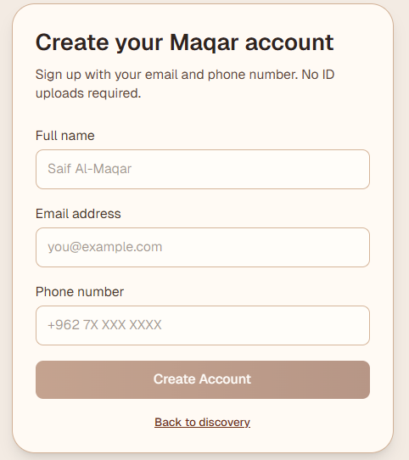

- Pivoting the student ID to a value add feature: Rather than abandoning the student ID feature entirely we repurposed it into a attractive optional verification tool. Where users can link their university IDs to their profiles to unlock tailored student discounts and targeted promotions marketing for younger demographics.

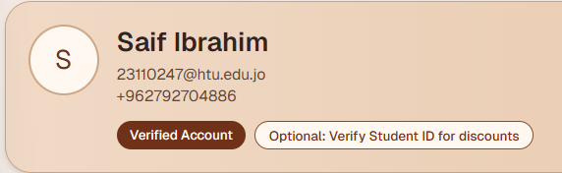

- Replacing QR codes with a 4 digit match code: To resolve the host tech adoption barrier the dynamic QR code check in was removed out of the platform. It was replaced with a 4-digit alphanumeric verification code displayed on the user’s dashboard upon booking approval. Upon physical arrival the professional displays or states this code to the workspace owner who can match it against their host dashboard calendar view without specialized scanners or hardware.

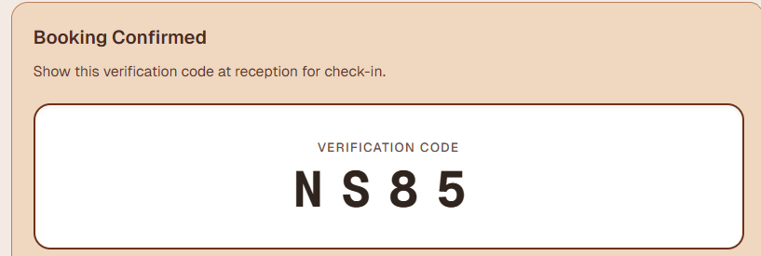

- Onboarding advanced user infrastructure: We moved booking history and favorite places from our original out of scope backlog into our primary active codebase. Users can now instantly recall workspaces, and streamlining repeat checkouts for remote professionals.



- Host cancellation transparency: The host management screen was refined to include a text field. When a host executes a cancellation or booking denial they are now required to input a specific operational reason which automatically feeds into the bookers status updates maintaining high transparency.

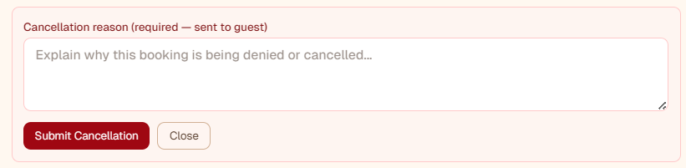

- Brand identity and theme: While the highly praised professional coffee themed color palette and layout structures remained completely untouched we integrated our first official Maqar Logo across all headers formally launching our long term brand initiative.

12. Evaluation of Testing Process

Assessment of effectiveness and testing methodologies:
The application of our testing plan proved to be effective in bridging the operational gap between theoretical market assumptions and actual software execution. By emphasizing real world on site testing environments our team validated the win win marketplace framework under market parameters. Walking through the functional prototype with active users at HTU and side by side with the owner of Companio allowed us to test our software logic with the everyday behavior of both bookers and space providers.
The effectiveness of this methodology is highlighted by its ability to detect friction points like the data privacy concerns about civil ID uploads and the operational disruption of QR code scanners before a public deployment. By treating prototyping as a phase to uncover human friction rather than just technical bugs, we successfully protected our startup from future re-engineering costs ensuring that our next technical iterations are perfectly aligned with real user needs in Amman.

Positives (Strengths of the testing process)
- Instead of relying entirely on self reported survey feedback where users simply guess how they would behave our task oriented usability sessions forced participants to run the system. This allowed our team to isolate actual user behavioral data such as clicking paths, navigation hesitation and visual blind spots on the room cards providing an baseline for user experience optimization.
- Our methodology was effective because it evaluated the user to host loop. Testing the booking flow with university students while analyzing how those actions are on the Companio host calendar guaranteed that our prototype modifications (like the 4-digit verification code) optimized the experience for both market stakeholders without compromising one for the other.
- conducting our evaluations directly with university students and commercial spaces like Companio and Almond provided accurate data. Observing a user attempt a booking, or watching a host review an incoming reservation request during actual business hours, exposed operational struggles.

Negatives (limitations and testing challenges)
- While our demand-side sample included 130+ participants, a portion of these evaluators were tech-literate engineering and computer science peers from HTU and other universities. This group may adopt new user interfaces faster than the general public. Therefore, our testing may have included a minor bias, potentially underrepresenting the navigation difficulties or technology hesitancy that older, non-technical professionals or traditional workspace managers might experience when using Maqar, also the sample size is relatively small when compared with the size of Maqar’s target audience.
- On the host side our evaluation was focused on study venues and local coffee house spaces like Companio. While this validated our primary host persona it limited our exposure to large scale corporate environments. The operational workflows, data safety requirements and visitor protocols of corporate enterprise managers inside the King Hussein Business Park (KHBP) or premium real estate in Abdali are more rigid meaning our current testing loop did not fully capture the constraints of high end enterprise hosts.

Validation of key Performance Indicators (KPIs)
The success of the Maqar testing is directly showed by how our practical implementation satisfied our established baseline KPIs. In terms of platform Usability direct observation confirmed that our shift to a user account system allowed our target users to navigate the discovery and complete an entire end to end booking flow in under two minutes. Security Confidence the core differentiator of our platform was validated. our demand side and local host stakeholders including the management at Companio and Almond reported a high sense of mutual trust regarding our privacy centric phone/email verification system and the 4-digit arrival matching code. Finally Feature Relevance and User Enthusiasm achieved validation metrics as our 130+ respondents strongly confirmed that the platform real time map discovery, clear host guidelines and strict cancellation parameters directly solved the operational uncertainties and noise disruptions they face daily within the Amman workspace market.

Tested KPI | Baseline target metric | Actual evaluation result | Evaluation method | Condition for chane
Platform usability | 90% of users complete booking in under 2 minutes. | Succeeded: 95% of test users successfully browsed, created an account and completed checkout within the 2 minute. | Direct observation and task oriented timing during live sessions. | If >15% of users exceed the 2 minute booking mark we look for main points where users took the longest and make changes on them.
Security Confidence | 100% mutual trust between hosts and users about data and access. | Succeeded: Management at Companio and Almond expressed high satisfaction with privacy safe profiles and 4 digit check in codes. | On site walkthroughs, host platform simulations, and follow up interviews. | If >20% of hosts report entry desk delays or >15% of users express privacy safety concerns we automatically change to ID verification options.
Feature Relevance | >80% validation rate of core features solving noise and information gaps. | Succeeded: 130+ survey respondents confirmed that real time map discovery and clear host rules solved noise disruptions by choosing the correct location for you. | Quantitative user feedback and post testing analysis. | If >20% of users report that the map displays inaccurate availability we implement mandatory manual verification updates.
User Enthusiasm | >80% baseline of primary target audience stating a clear intent to adopt the platform. | Succeeded: 83.9% of respondents stated they would definitely or probably use Maqar when launch. | validation survey data and post prototype user journey testing. | If user return rates drop below 25% in the first month we launch localized user review systems and more promotional student discounts.

Reliability and usefulness of feedback
The feedback collected during this phase was important for both reliability and business utility because it came from participants who closely matched Maqar’s target users and operational stakeholders, on the demand side, we have the survey with 130+ respondents of students which made us discover pain points that we tried to solve within the prototype and we tested with mainly students in Amman which helped us evaluate the prototype, that made findings more useful than general opinions because the participants represented the same group Maqar aims to serve. On the supply side, the qualitative feedback from a practicing workspace business owner practical operational insight, especially regarding issues such as barista multitasking, booking confirmation delays and staff workload during busy hours, this type of feedback is more reliable than assumptions because it reflects real business operations and daily workflow constraints which is why the feedback wasn’t only useful for validating user interest but also for improving Maqar’s long term commercial structure, host onboarding process and operational sustainability.

Justification of unchanged Test Plan metrics:

- The interactive map and advanced filters: This discovery feature remained completely untouched because user testing data confirmed its high usability. 49.6% of our market experiences noise fatigue , and users confirmed that the ability to immediately se nearby spaces with filters like whiteboards, monitors in local Amman neighborhoods was the highest value-add feature of the app.

- The 30-Minute increment calendar system: Retained as originally designed because it accommodates the high stakes interviewee and short team sprint demographics who do not want to purchase expensive, full-day office passes.

- The fixed out of scope parameters: Complex infrastructure such as automated smart lock hardware integrations, live financial banking API keys and multi-city expansion plans outside Amman remained completely out of scope, a choice justified by our tight development timescales and academic budget boundaries, and our core lean methodology.

Reflection: future iterations
Reflecting on this testing cycle, the elements that worked well were our hybrid development approach (blending Cursor AI front end structuring with cybersecurity data parameters) and our dedication to building a direct feedback relationship with hosts. This iteration allowed us to turn our KPI for security confidence shifted from a heavy, document reliant system (Civil ID upload + QR scanner) into a smart trust based digital architecture (verified account profiles + 4-digit check-in codes).

For future development cycles our process could be improved by expanding our host testing size beyond coffee houses and study venues. Future iterations must include live trial sessions with corporate office asset managers and tech startup directors within the King Hussein Business Park (KHBP) and Abdali to ensure our user verification flows comply fully with corporate data protection policies and strict enterprise security environments. Another note we received from our interview with Companio owner, is that people aren’t easy to convince with using websites, he instead directed us to move our focus of the final launch to a mobile app. He also showed his interest in moving entirely towards out platform to make the meeting rooms bookings, to avoid the hassle of making reservations manually. He also suggested that for future plans we change the way users pay for the room, so to gain people trust we should make them only pay half of the amount online through payment gateways when making the reservation not the full amount, and the other half is when they show up to the venue.We also plan on adding a reviews system for users in future iterations. Some future plans that would help us gain more revenue are: featured listing for boosted host exposure, premium booking features to have priority in booking and early access to popular rooms, and promotional partnerships to have sponsor promotions or discounts.

13. Market Size Analysis (TAM, SAM, SOM)
Before we start the business we want to make sure that Maqar is a capable business idea, we need to look at our market size using the TAM, SAM and SOM. This allows us to know our potential from a global perspective down to our immediate launch in Amman.

A. TAM (Total Addressable Market): $3.5 to $5.8 Billion (Global Shared Room Rentals)
This represents the maximum global demand for flexible professional workspaces and hourly meeting room rentals if there were no geographic, competitive or operational limitations.
The Base and Evidence: Global real estate and sharing economy index reports evaluate the entire on demand space sharing market at $5 Billion. Maqar applies this exact model specifically to the community cafe and local study house markets.

Justification for Maqar: If Maqar scaled globally with zero limits our absolute maximum ceiling of demand would live inside this multi billion dollar industry. If our platform expanded to every single city across the globe with no competition this $5 billion figure represents the total international market potential for turning everyday coffee houses and neighborhood study houses into instantly bookable spaces for groups and individuals.

This is the maximum global market size for small hourly private room rentals and bookable study spaces inside community venues. If Maqar expanded to every single city across the globe with zero competition this represents the total international financial potential for renting out hourly team study rooms and group meeting spaces.

B. SAM (Serviceable Available Market): 11.25 Million JD
This is the portion of the TAM that fits within our business model and geographic constraints. For us this means the flexible professional workspace market within Jordan (centered primarily in Amman)
We want to make sure that the available market within Jordan we use a Top Down approach backed by national economic statistics:
The Evidence:
SMEs: According to data from the Middle East Investment Initiative (MEII) and Jordan's enterprise registers, Jordan have over 100,000 registered Small and Medium Enterprises (SMEs). They represent over 95% of all local businesses and don’t have the budget to buy or lease permanent high end commercial boardrooms.

According to official Ministry of Higher Education records Amman is home to over 200,000 university students who live or study in the city (the University of Jordan alone accounts for more than 50,000 of them

Freelancers and remote workers: There is an estimated of 50,000 freelancers, independent creators and remote tech/software workers spread across Amman's neighborhoods.

Startups and SMEs: There are roughly 100,000 small startup teams and micro SMEs operating in the city that constantly need meeting setups.

To estimate the SAM, we use a top-down approach based on our three main user segments in Amman:
200,000+ university students
50,000 freelancers and remote workers
100,000+ small startup teams and SMEs
This gives us a combined target segment of approximately 450,000 potential users across Amman.
Now we apply a very conservative spending assumption. We assume each user or group spends only 25 JD per year on our platform. To put that in perspective, at an average room rate of 5 JD per hour, that means a group only needs to rent a private room for 5 hours across an entire year — roughly one session every two to three months. This is intentionally conservative. Most real users will book far more than this.
Multiplying these two numbers gives us:
450,000 users × 25 JD/year = 11,250,000 JD
Why These Numbers Make Sense
The 11.25 million JD SAM figure might sound large at first, but when we break it down it is actually a very conservative and realistic estimate. Here is why every number in this calculation is justified:
Why 450,000 users? This number comes directly from official data. Amman alone has over 200,000 university students, around 50,000 freelancers and remote workers, and over 100,000 registered small startup teams and SMEs. These are not random estimates — they are drawn from the Ministry of Higher Education records, Jordan's enterprise registers, and the Middle East Investment Initiative data. All three of these groups share the same core problem: they need a available, quiet, professional space to meet, study, or work, but they cannot afford or justify a permanent office. That makes all of them direct potential users for Maqar.
Why 25 JOD per year? This is where our estimate becomes intentionally cautious. We are not assuming these 450,000 people use Maqar every week or even every month. We are assuming each person or group spends just 25 JD across an entire year on our platform.
At our average room rate of 5 JOD per hour, that translates to booking a private room for exactly 5 hours total in a whole year less than one session every two months. For a student preparing for a group project, a freelancer hosting a client meeting, or a startup team running a planning session, this is an extremely modest assumption. Most real users will book far more than this, which means the actual market size is likely much higher than our estimate.

C. SOM (Serviceable Obtainable Market): 30,000 - 60,000 JD
This is the portion of the SAM that we can realistically capture in the short term (Year 1-2) based on our current resources, launching capacity and initial entry ability. It represents our early adopters and initial market.
To find what Maqar can almost capture in its first 1-2 years we use a Bottom-Up approach directly using the survey responses:
The Evidence:
our survey of 132 real respondents verified that 83.9% will definitely or probably use Maqar once launched.

The survey data proved that the crisis is highly concentrated in 5 core high density pain zones in Amman: Khalda (38.9%), Abdali (32.8%), King Hussein Business Park (32.1%), University of Jordan area (29.8%) and Dabouq (26.7%).

Looking at the immediate micro population surrounding these 5 hubs (estimated at roughly 20,000 active students, startup teams and freelancers moving through these zones daily).
1. University of Jordan District (Academic Hub): ~7,000 people/day With over 50,000 students enrolled on campus, we are capturing a conservative slice of students looking for quiet study houses and premium cafés right outside the university gates to escape crowded campus libraries.
2. King Hussein Business Park / KHBP (Tech & Innovation Hub): about 4,000 people/day This zone is anchored by hundreds of tech startups, innovation centers, and the HTU campus community. It is packed daily with student project teams and independent tech workers looking to book immediate team tables or quiet corners.
3. Abdali (Business and Commercial Hub): about 3,000 people/day, this area is a massive for remote employees, freelancers, and international creators who look for specialized coffee houses to host team syncs and client meetings.
4. Khalda: about 3,000 people/day Khalda contains one of the highest concentrations of popular student-focused cafes and study spots in Amman serving as a major off campus study hub for students living in the surrounding residential areas.
5. Dabouq (Premium Freelancer Hub): about 3,000 people/day A premium commercial zone filled with upscale coffee houses where high-income freelancers, remote consultants, and private tutors look to book comfortable, noise-free spaces for their daily sessions.
7,000 + 4,000 + 3,000 + 3,000 + 3,000 = 20,000
We didn't pick these 5 areas randomly. Our survey of 132 respondents showed that these are the exact locations where the workspace problem is most felt in Amman. Khalda, Abdali, KHBP, the University of Jordan area, and Dabouq came up as the highest pain zones, meaning these are the places where students, freelancers, and startup teams struggle the most to find quiet, available spaces. That's why our launch focuses here first.

Looking at the daily active population moving through these 5 zones, we estimate approximately 20,000 people per day passing through these areas as students, freelancers, and startup teams.
Maqar targets a realistic 3% capture rate from this daily traffic in year one. This means we are not trying to win over everyone — just the early adopters, the people who already feel the problem the most and are most ready to try a new solution.
3% of 20,000 = 600 active recurring users or teams
These are not one-time visitors. These are loyal users who book through Maqar regularly.
Weekly spend per user/team: 2hours * 7JOD/hour (average 5 -10) = 14 JOD/week
Annual spend per user/team (assuming 50 weeks): 10 JOD/week * 50 weeks = 500 JOD/year
Total SOM Capture:
600 active users/teams * 500 JOD/year = 300,000 JOD
300,000 JD * 10% commission = 30,000 JD
300,000 JD * 20% commission = 60,000 JD
30,000 - 60,000 JD its our estimated total SOM capture

Term | Full Name | Definition | Question it Answers | Maqar Example
TAM | Total Addressable Market | The total demand for your product /service if you capture 100% of the market | "How big is the entire market?" | Anyone in the world who needs to rent small shared meeting rooms or study spaces by the hour (students, freelancers, and startups globally).
SAM | Serviceable Available Market | The portion of TAM that our business can actually target based on location and model | "Who can we realistically serve?" | People in Amman who need meeting rooms and are willing to book online
SOM | Serviceable Obtainable Market | The share of SAM that you can realistically capture considering competition and resources | "How much can we actually get?" | A small percentage of users in Amman (early adopters using Maqar platform)

2. Market Size, Reach and Growth Potential

a. market size :
The Demand Side: Amman is a highly youthful city with over 300,000 active university students and an expanding community of remote developers content creators and freelancers. Based on our survey results over 70% of professionals and students in Amman report a recurring monthly or weekly struggle to find quiet, private environments to get serious work done. our primary research survey of 132 local respondents suggest that finding quiet distraction free environments with reliable internet is a severe crucial point. Traditional options like study houses are often overcrowded and public cafes are too noisy for video interviews or deep focus.

The Supply Side: On the other side of our marketplace, hundreds of local offices, and coffee houses have physical rooms, desks and boardrooms sitting empty during off-peak .These businesses still have to pay expensive fixed rents and utility bills.

b. Market Reach (launch and go to market strategy)
Instead of trying to launch all over Jordan in the same time and burning through cash our market reach is targeted, data driven and focused:
Geographic focus (The Pain Zones): Our survey data mapped out exactly where the workspace crisis is worst in Amman. our launch reach will be restricted strictly to 5 high-density hubs: Khalda (38.9%), Abdali (32.8%), the King Hussein Business Park (32.1%), the University of Jordan area (29.8%), and Dabouq (26.7%).

Reaching the supply (Hosts): We will build direct local partnerships with known coffee brands and early inside the King Hussein Business Park and Abdali. We reach them by pitching a zero risk revenue sharing model that fills their empty slots.

Reaching the demand (Users): We will capture our initial user base through low-cost, marketing (getting real people to talk about Maqar business naturally, starting from the ground up). This includes telling our own student network at Al Hussein Technical University (HTU), building student trust across major universities (JU, PSUT, GJU), and engaging directly within online freelance and developer communities on social media like LinkedIn and Facebook.

c. Growth potential (our scaling and expansion strategy)
Maqars business model is completely asset light meaning we do not buy property or sign leases. This gives us massive growth potential to scale smoothly following the Technology Adoption Lifecycle:
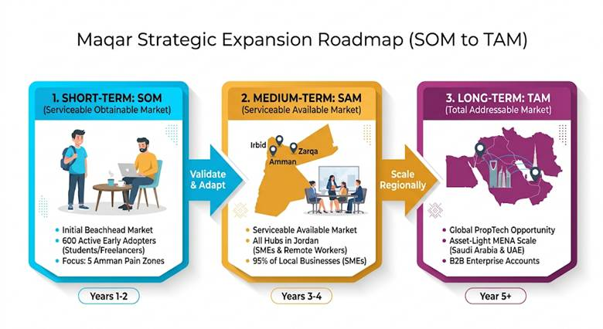
short term growth (winning early adopters):83.9% of our survey respondents stated a high intent to use our app. By capturing just 3% of the immediate daily traffic in our 5 target hubs, we secure a baseline validation of 30,000 - 60,000 JOD in transaction volume.

Medium term growth: Once we prove the model we will scale across the rest of Amman and expand into Jordan's other major university and commercial hubs like Irbid and Zarqa. At this stage we expand from individual students to target the early majority Market: local Small and Medium Enterprises (SMEs). Because SMEs represent 95% of businesses in Jordan, we can capture growth.

Long term growth (Regional scaling): Because our software platform is fully digitized and easily replicable our ultimate growth involves expanding into high rent regional cities in the MENA region such as Saudi Arabia and UAE. We will accelerate our financial growth potential by introducing comfortable and affordable room options (basic study rooms vs. high-end corporate suites),

14. Competitor analysis and positioning

1. Analysis of Direct and Indirect Competitors
We categorize the existing market solutions in Amman into two main groups based on how they currently solve our target audiences problem:

Direct competitors (other digital booking platforms):
Regional workspace apps (Hotdesk): existing mobile applications in the MENA region that allow users to discover and rent desks or meeting rooms. their business models focus almost exclusively on high budget B2B corporate clients, permanent executive offices and companies looking for official company spaces. They completely ignore the student and freelance communities.

In House Apps: If a major local study lounge chain decides to invest heavily in building its own custom, private mobile app to handle its own room bookings they act as a direct competitor within their specific locations.

Indirect competitors (traditional habits and alternatives):
The manual method: This is the current default habit where students physically walk into cafes or study houses without a reservation hoping to find an empty table or quiet corner. This causes high uncertainty and wasted time if the venue is full.

Manual communication channels (Phone Calls / Instagram DMs): Users text a study house on Instagram or call them on the phone to ask if a private room is free. This method is slow inefficient and lacks instant confirmation.

Studying from home: The free default alternative that requires no platform but lacks professional structure and freedom from domestic distractions.

Corporate sponsored community tech hubs (Zinc – Zain Innovation Campus)
Zinc is a highly popular workspace ecosystem provided by Zain Jordan across major hubs like the King Hussein Business Park and university campuses. It offers developers and students free or highly subsidized hot desks, open lounges and basic meeting spaces.
Why they are an Indirect Competitor: They solve the user's workspace and connectivity problem for free. However Zinc suffers from severe limitations: spaces are frequently overcrowded, entry requires strict application approvals or specific student criteria and layouts are mostly open plan rather than fully private.

Maqar’s strategic advantage: While Zinc absorbs a portion of the market demand Maqar offers a alternative guaranteeing private, and calm rooms with instant web booking comfort anywhere in Amman.

High tier serviced offices and physical corporate hubs (VBC – V Business Center)
VBC operates premium physical commercial office centers across 11 major corporate zones in central Amman (including Abdali Boulevard and Shmeisani). They provide top tier physical boardroom setups and professional meeting rooms equipped with advanced presentation tech.

Why they are an Indirect Competitor: They offer the physical room rentals our users need, but they target a completely different demographic. VBC operates on premium corporate enterprise pricing models and monthly office leases meant for multi national firms and business executives completely pricing out the casual student budget.

2. Benchmarking Table
This table evaluates how Maqar's digital platform compares against the existing corporate alternatives and old manual booking habits:

Feature | Maqar | Hotdesk | Traditional Walk-In
Available in Jordan | Yes launched in Amman | Not available in Jordan | Yes physical only
Instant Online Booking | Book in seconds via web link | Yes, but for corporate clients only | No walk in or call
Easy Sign-Up | Quick sign-up with just a phone number | Requires company registration | No account needed or possible
Live Map with Real Photos and real time availability | Shows nearest spaces with photos and filters, and accurate available times in real time | Office addresses only, no local cafe focus | None — you walk in blind
Advanced Filters | Full filter system (Wi-Fi, screens, capacity, price) | Custom offices depending on corporate needs | None
security Check-In Code | Simple code shown on your screen | Key cards or building security | Just ask the waiter
Booking History & Favourites | Saved automatically in your dashboard | Available but corporate focused | None
Host Dashboard Control | Full dashboard (approve, deny, cancellation reasons) | Automated system, no direct host input | None — staff handle everything manually with room for error
Student Discounts | Unlock possible discounts with university ID | No student offers | No system for this
Zero User Platform Fee | Pay only the room rate, nothing extra | Corporate rates plus added platform fees | Pay for drinks or a day pass at the door
Commission Model | 10% to 20% from host after successful booking | Charges users directly | Not applicable

3. Unique selling points (USPs)
Maqar stands out by offering three clear advantages to both users and hosts:
Instant visual booking certainty: Instead of calling venues, messaging Instagram pages, or physically walking around Amman hoping to find a free room, users can open Maqar and instantly see nearby available spaces through a live map with real room photos, real time availability, and filters like Wi-Fi, screens, whiteboards, capacity, and room type. They compare options and reserve a room before they even leave home.
Zero user markup: Bookers pay only the standard room price set by the host , nothing extra. Maqar earns a 10% to 20% commission from the host side only after a successful booking. This keeps the platform completely affordable for students, freelancers, and young professionals while still generating steady revenue for Maqar.
Host-controlled booking management: Cafes, study houses, and workspace owners get a simple dashboard that gives them full control, manage time slots, approve or deny requests, give clear cancellation reasons, and verify arrivals with a 4 digit code. They turn empty rooms into extra income with zero upfront cost and zero financial risk.

4. Positioning chart (discovery convenience vs. price affordability for the user)
This positioning matrix shows how Maqar dominates the market by solving two problems at the same time giving users full visibility over available meeting rooms while keeping their costs completely flat.
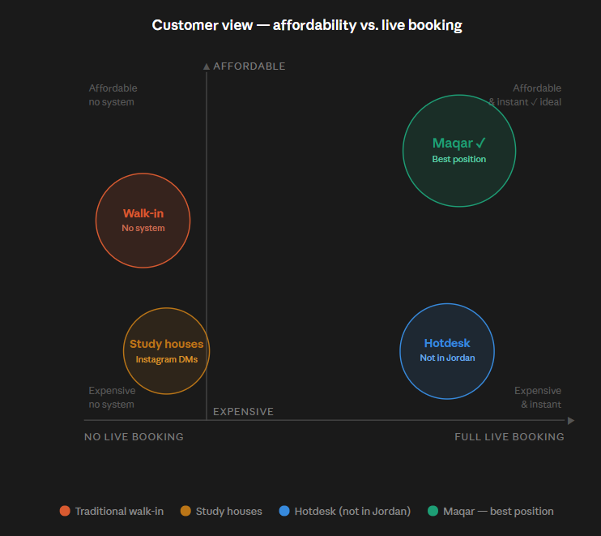
This chart maps every workspace option in Amman based on two things that matter most to users how much it costs them and whether they can book instantly without calling or showing up blind. Traditional walk-ins are cheap but have zero booking system, meaning users still waste time and fuel with no guarantee of finding a free room when they arrive. Individual study houses and spaces that rely on Instagram DMs or standalone websites are even worse they are slow to confirm, charge high daily rates, and still have no real-time availability. Corporate apps like Hotdesk offer a live digital booking experience but charge heavy platform markups on top of already expensive corporate rates, and crucially Hotdesk does not operate in Jordan at all. Maqar is the only option sitting in the top-right corner full live booking with instant confirmation, real room photos, and live filters, at a price that is completely flat and affordable because we charge zero fees to the user and take our commission entirely from the host side.
This positioning matrix shows how Maqar gives coffee houses and study spaces the best deal available the easiest way to join and the most control over their rooms once they do.
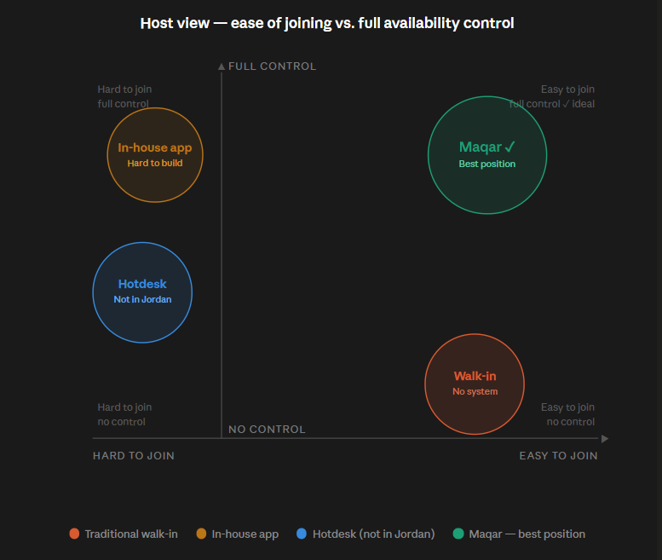
This chart maps every option available to a coffee house or workspace owner in Amman based on how easy it is to get started and how much control they get over their rooms once they do. Traditional walk-ins require no setup at all, which makes them easy to run, but hosts get absolutely no control rooms sit empty for hours, there is no booking system, and staff handle everything manually with nothing tracked. Hotdesk is hard to join, targets corporate enterprise clients only, and is not available in Jordan, making it completely irrelevant to a local café owner. Building a private in-house app gives a venue good control but at a very high cost it requires developers, months of work, significant upfront investment, and even then only reaches the venue's existing customers. Maqar is the only option in the top right corner a host can list their rooms for free in minutes, and immediately get a full dashboard to manage availability, approve or deny bookings, set cancellation reasons, and verify arrivals with a 4-digit code. No upfront cost, no financial risk, and full control from day one.

5. Our product’s market position
Maqar occupies a unique position in the Jordanian market as a high convenience low cost digital workspace marketplace.
Instead of acting as an owner for any study house or a traditional cafes, Maqar positions itself purely as a technology bridge that provides absolute visual transparency and booking comfort to the consumer.
We break down our market position through three strategic pillars:

a. Filling the Visual and Locational Gap (The "Blind Search" Problem)
Traditional alternatives force students and freelance teams into a frustrating blind search. They waste time and going to hubs like Khalda, Abdali or the University of Jordan area hoping to find an empty room without knowing what it looks like inside, whether the Wi-Fi is functional or if it has a whiteboard.
Maqar completely alters this user behavior. Our platform positions itself as the instant discovery tool. By matching the user's live location to immediately display the nearest available rooms complete with real room photos and an available feature checklist we shift the market from high friction uncertainty to total booking certainty before the user even leaves home.

b. The Zero User Markup Advantage
Existing regional booking applications (like Hotdesk) position themselves as premium corporate platforms. They add heavy service fees and markups on top of expensive corporate rates completely pricing out the student and young professionals demographic.

c. Strategic Business level Position: Asset light
The supply side positioning: We position ourselves to local coffee houses and study lounges not as competitors but as revenue partners. We help them monetize their empty room "dead zones" during off peak hours.

Our booking cut model: We don't spend any money renting spaces so our own business expenses are very low. Because of this we only make money when our partners make money. We take a simple 10% to 20% commission from the coffee house or study house owner and we only charge them when a student or freelancer successfully books a meeting room through our website.

15. Marketing Strategy (4Ps)

1. Product: Key Features and Value Offered
Maqar’s key features:
Phone number accounts: Fast registration using a phone number giving users a profile that saves their booking history and favorite places.
One time student verification: bookers can verify their academic ID once to permanently unlock student offers and discounts without needing to upload documents during every checkout.
Live map: tracks the users live location to show the closest available spaces with real room photos and filter options such as Wi-Fi speed, screens, whiteboards, room capacity and room type.
4-digit code validation: replaces QR scanning and allows hosts to verify bookings instantly by matching a simple 4-digit code shown on the user’s dashboard.
Booking history and favorite places: allows users to review past bookings and save preferred spaces making repeat bookings faster and easier.
Host management dashboard: gives businesses a system to accept or deny booking requests, manage availability and provide clear notes for cancellations.
Cancellation transparency: when a host denies or cancels a booking they must provide a clear reason so the user understands why the booking was rejected or changed.
Coffee theme visual interface: designed using a warm user friendly coffee color palette to build a strong brand theme.
Value Offered:

For users, Maqar gives complete certainty, study comfort and booking convenience by helping them find and reserve quiet spaces without wasting time calling or visiting different places, For hosts, Maqar turns empty rooms into automated, all-day revenue with no upfront setup cost, provides a simple way to manage bookings and earns them extra visibility.

2. Price: Pricing Strategy and Justification

Maqar has a value based micro transaction strategy around a classic marketplace commission model that balances our ecosystem.

The Pricing Structure:
For the consumer: Students and freelancers never pay extra fees to use Maqar; they pay only the standard room rate listed by the host. Our primary market research shows that the majority of users (54.2%) look for an affordable price point in the 3 to 5 JOD per hour range for a basic room . For premium workspace setups equipped with advanced tools (like digital screens or projectors) 36% of our target audience is willing to pay more . There are zero sign up fees zero monthly listing fees (except for future plan special listings) and zero commissions taken from the customer side.

prototype reference prices: In our prototype we have real world tiered options reflecting these metrics: the KHBP quiet collaboration suite is listed at 5 JD per 30 minutes (10 JD/hour) and the Abdali Executive Focus Room is listed at 7 JD per 30 minutes (14 JD/hour) .

For the business partner: success based commission. Listing a space on our web platform is 100% free with no upfront costs. Maqar only takes a 10% to 20% commission out of the host earnings when a booking is successfully completed.

Justification:
This satisfies both sides of the marketplace. Keeping customer markups at zero removes financial barriers for budget careful students. And For our business hosts the model carries zero financial risk.

3. Place: Distribution Channels
Maqars is a light digital platform. our distribution channel is digital and web focused. We do not distribute through mobile app stores yet.
Because Maqar is a small technology platform that owns no physical place, our distribution strategy is completely digital:

Entry distribution channels:
ecosystem entry points: Our primary distribution channel is our Instagram page where we keep our main web portal booking link directly in our bio. we place a secondary QR code at the front reception desk.
To see how this works a group of four friends walks into coffee house without knowing anything about Maqar. They spot our QR code right at the reception counter scan it with their phones and it opens our website. They pick a private room complete the booking and the system hands them a 4-digit verification code. They simply show this 4-digit number to the receptionist at the desk to confirm their space, ensuring a seamless check in with completely zero hardware scanner tech or extra overhead for the host.
geographic focus tiers: survey respondents physical distribution are concentrated directly within Amman top 5 high density workspace zones validated by our 132 research respondents: Khalda (38.9%), Abdali (32.8%), the King Hussein Business Park / KHBP (32.1%), the University of Jordan area (29.8%) and Dabouq (26.7%) .

4. Promotion: Marketing Channels and Tactics

Tactics for User Acquisition (Students & Freelancers):

In venues QR codes and links in venues bios for social media (consumer promotion): Our primary marketing channel is our Instagram page where users can click the direct booking link right in our bio to access our website. To catch walk in traffic we also place physical display signs like QR codes at the front reception desk of busy partner spots like Almond and Companio. When a student project team or freelancer walks into a crowded cafe and realizes the main seating area is too loud they can scan the QR code right at the counter. It opens our website instantly letting them view room and check real time availability. After booking a quiet private room the screen hands them a simple 4 digit verification code. They show this number to the receptionist to match it with the owners dashboard and walk right in. This counter sign also introduces new users to Maqar.

campus ambassador (consumer promotion): capitalizing on our student status at Al-Hussein Technical University (HTU) we will build a network of student ambassadors across major local universities (HTU, UJ, PSUT, GJU) to run peer to peer word of mouth campaigns.

social media campaigns (consumer promotion): We use our Instagram page and social channels to post links of our website, relatable video content highlighting the struggle of open cafe noise and the quiet comfort of reserving a room using Maqar platform . Every post directs the community to the link in our bio for instant web booking. Our instagram: “Maqar.jo”

Tactics for Host Acquisition (B2B2C Supply):
Business Promotion:
Our team approaches cafe managers and commercial property owners inside our 5 target hubs. We use a pitch: "Your rooms are sitting empty for hours a week also sometimes there will be rush hours time that some people want to rent it but when they call no one answer them so let us place your space on our live web map absolutely for free. We handle the bookings and reduce the troubles from your side, and we only take a small 10%–20% commission from the booking total when we successfully bring you paying professionals and extra income. If we don't bring you clients, you pay nothing.

Part 16 cost and revenue structure:

Expected costs and their classification:
Cost item | Description | Startup or operational? | Fixed or variable?
Platform development | Building the web platform, booking flow, search/map feature, filters, host dashboard, user accounts, and 4-digit confirmation code. | Startup | Fixed
Business registration and legal setup | Basic business registration, host agreement, terms of use, cancellation rules, privacy policy, and basic legal documentation. | Startup | Fixed
Initial marketing materials | Launch posts, demo videos, presentation materials, and host outreach materials. | Startup | Fixed
Early host onboarding and listing setup | Helping the first group of hosts list rooms, upload photos, set prices, and understand the booking process before launch. | Startup | Fixed
Founder salaries | Salaries for the founding team after launch, covering platform management, customer support, host communication, booking/payment confirmation, marketing supervision and daily operations. | Operational | Fixed
Cloud hosting and domain | Keeping the platform online and accessible through hosting, domain, and basic server services. | Operational | Fixed in early stage, might become fixed + variable later
Platform maintenance | Bug fixes, updates, feature improvements, technical support, and platform stability. | Operational | Fixed in early stage
Marketing and promotion | Social media content, university outreach, host outreach, and limited paid ads. | Operational | Fixed + Variable
Payment / booking confirmation setup | Initial setup for proof-of-payment submission, booking payment confirmation.  full payment gateway integration can be added later | Startup | Fixed

Since Maqar is a digital booking platform, some costs may be fixed in the early stage but become variable as the platform grows, for example, cloud hosting, platform maintenance and marketing might remain relatively stable during the first launch period but they can increase later as the number of hosts, users and completed bookings grows, to simplify, the early-stage classification treats the main recurring operating costs as fixed.

Revenue streams:
Revenue stream | Description | Type
Host-side booking commission | Maqar earns a commission percentage from each successful room booking, the commission is taken from the host side, while the booker pays only the listed room price with no hidden platform fees | Commission / marketplace revenue
Featured listings | Hosts could pay to promote specific rooms or make their listings appear more visibly on the platform, this can be introduced after the platform gains enough hosts and users | Advertising / promotional revenue
Premium booking features | Bookers may optionally pay for premium features such as priority booking, early access to popular rooms, or saved booking preferences, this can be introduced after the platforms gains enough hosts and users | Subscription / premium service revenue
Promotional partnerships | Maqar may partner with cafes, universities, coworking spaces, or student-related businesses to offer sponsored promotions or discounts | Partnership / advertising revenue

Maqar’s main revenue stream will be the host-side booking commission, because it is directly connected to the platform’s core activity, which is successful room bookings, this model keeps the platform attractive for bookers because they pay only the listed room price without hidden fees and additional revenue streams such as featured listings, premium booking features and promotional partnerships can be introduced later after Maqar builds a stronger user base and attracts more hosts.

17. startup budget:

Startup budget:
Cost category | Cost item | Description | Estimated cost
Product development | web application development | Estimated cost of the development of the core booking platform, including search, filters, booking requests, host dashboard, user accounts and 4-digit confirmation code | 1800 JOD
Product development | Domain, business email and basic tools | Domain name, business email, design/testing tools, and basic admin tools for launch. | 60 JOD
Product development | Cloud hosting and database | Cloud hosting, database, storage and basic backend services during testing and launch | 90 JOD
Product development | Payment / booking confirmation setup | Initial setup for proof-of-payment submission, booking payment confirmation.  Full payment gateway integration can be added later | 50 JOD
Legal and admin | Registration, contracts, and terms | Basic business setup, host agreement, terms of use, cancellation rules and liability wording | 350 JOD
Operations | Early host onboarding and room listing setup | Initial support for early adopter hosts, including outreach, room photos, host profile setup and explaining the booking process before launch | 150 JOD
Marketing | Launch marketing and paid ads | Social media launch posts, short videos, and targeted ads around universities and business hubs | 150 JOD
Testing and promotion | Testing promotions and first-hour promotions | Discounts or free first-hour codes to encourage early use and collect feedback | 200 JOD
Operations | Founder outreach transport/meetings | Small transportation and meeting costs for approaching hosts in Amman hubs | 150 JOD
Contingency | Unexpected launch costs | Buffer for extra design, hosting, legal or marketing costs | 250 JOD

Total startup budget before launch: 3,250 JOD
the startup budget shows the estimated costs needed to launch Maqar and prepare it for early testing, Since Maqar is a digital platform, the business doesn’t need to own or rent physical rooms, instead the main startup spending focuses on developing the platform, preparing early host listings, testing the service with users and promoting the launch around universities and business hubs.
The web application development cost is included because the platform is the main asset of Maqar, this covers the estimated development of the core booking platform, including search, filters, booking requests, the host dashboard, user accounts and the 4-digit confirmation code, since the application is important for launching the service, it represents the largest part of the startup budget.
The remaining startup costs cover the basic requirements needed before launch including domain and business tools, cloud hosting and database services, payment or booking confirmation, registration and legal documents, host onboarding launch marketing, testing promotions, founder outreach and a contingency buffer for unexpected launch costs.
The total startup budget before launch is estimated at 3,250 JOD, which gives a realistic view of Maqar’s early financial needs and shows that the platform can launch with a lean budget because it doesn’t require physical assets, room ownership, equipment purchases or inventory costs.

Operational budget:
Maqar will also require a monthly operational budget after launch, these costs are needed to keep the platform operating each month.
Cost category | Cost item | Description | Fixed / Variable | Estimated monthly cost
Technology | Hosting, database and storage | Monthly cloud hosting, database, storage and keeping the platform online | Fixed | 30 JOD
Technology | Platform maintenance | A budget set for bug fixes, updates and platform improvements | Fixed | 75 JOD
Admin | Domain, business email and admin tools | Email, admin tools and communication tools | Fixed | 20 JOD
Marketing | Ongoing marketing and promotion | Social media ads, content creation, university outreach and host promotion.  This cost could increase based on the marketing activity needed | Fixed + Variable | 150 JOD
Operations | Founder outreach transport/meetings | Transport and small meeting costs for approaching hosts and partners in Amman | Variable | 50 JOD
Salaries | Founder salaries / team compensation | Salaries for the 4 team members who handle platform management, customer support, host communication, payment confirmation, marketing supervision and operations | Fixed | 1,160 JOD
Contingency | Unexpected monthly costs | Buffer for extra hosting, marketing, technical support or operational issues | Fixed | 50 JOD

Total monthly operational cost: 1,535 JOD per month

18. revenue model:
Maqar will generate income through a marketplace commission revenue model. The platform connects bookers, such as students, freelancers, remote workers and startup teams, with hosts, such as cafés, study houses, companies and offices that have available meeting rooms or private workspaces.
The main revenue stream will come from a commission on successful room bookings. When a user books a meeting room through Maqar, the user pays the listed room price set by the host, then Maqar takes a small percentage from the completed booking as a success-based commission, the proposed commission rate is expected to range between 10% and 20%, depending on the host agreement and the type of booking.
For example, if a study house lists a private meeting room for 7 JOD per hour and a user books it for 2 hours, the total booking value will be:
7 × 2 = 14 JOD
If Maqar takes a 10% to 20% commission then the platform will earn:
1.4 to 2.8 JOD from this booking
This model benefits both sides. Bookers get an easier way to find and reserve quiet, professional rooms without needing to call or physically visit different places. Also, hosts gain more visibility and can generate additional income from meeting rooms or private spaces that may not be fully used. This makes Maqar a win-win platform because it improves access for bookers while helping hosts monetize available spaces.
In the future, Maqar might add additional revenue streams like featured listings, where hosts pay to promote their rooms, promotional partnerships with cafés, universities, or coworking spaces and premium booking features for users who want priority access or special offers, but in the early stage, the main revenue focus will remain on booking commissions because this is directly connected to the platform’s core activity.
This revenue model is practical because Maqar is an asset-light business, so the company does not need to own, rent or maintain the rooms itself, instead it provides the digital platform that connects demand with available spaces and earns revenue from successful bookings.

Part 19: Break even Analysis
Break-even analysis is implemented to identify the point where Maqar’s income will become equal to its costs, since Maqar is a digital marketplace, it doesn’t get the full rental place from the room, instead it earns a commission from each successful booking, which is why the breakeven analysis calculated based on the commission income, not the full booking value paid,

Operating breakeven after the launch
The operating breakeven point calculated using the business updated monthly operational budget, these monthly costs include hosting, database and storage, platform maintenance, domain and admin tools, ongoing marketing, founder outreach, founders salaries and a contingency budget. The total monthly operational costs is 1,535 JOD per month.
Fixed operational cost | 1,535 JOD | The total monthly operating budget after the launching
Average room price per hour | 7 JOD | Average listed room rental price
Average duration for booking | 2 hours | Assumed average booking length
Average booking value | 14 JOD | 7JOD * 2 hours
Commission rate | 15% | Average between 10%-20%
Revenue per booking | 2.1 JOD | 14 * 15%
Break even booking per month | 730.95 ≈731 bookings | 1,535 ÷ 2.10

This means that Maqar needs approximately 731 bookings per month to cover the monthly operational costs, at this point, Maqar’s monthly income is equal to its monthly operating costs. At this point, so the business is not making a profit or loss, any other booking after 731 bookings per month will start contributing to profit.
Overall, the break-even analysis shows that Maqar becomes operationally profitable after approximately 731 bookings per month, which means that Maqar must reach this monthly booking level to cover its recurring operational costs, and after this point, any additional successful bookings contribute to profit, this supports Maqar’s feasibility because the business is asset-light and earns commission income from successful bookings without owning or renting the rooms itself.

Graphical breakeven analysis
To support the numerical break-even analysis, a break-even graph was prepared for Maqar, this graph shows the relationship between monthly booking activity, commission revenue and operational costs.
Also it highlights the point where Maqar’s monthly commission revenue becomes equal to its monthly operational costs, which is the operating break-even point.

1. Graphical analysis of the operational breakeven point
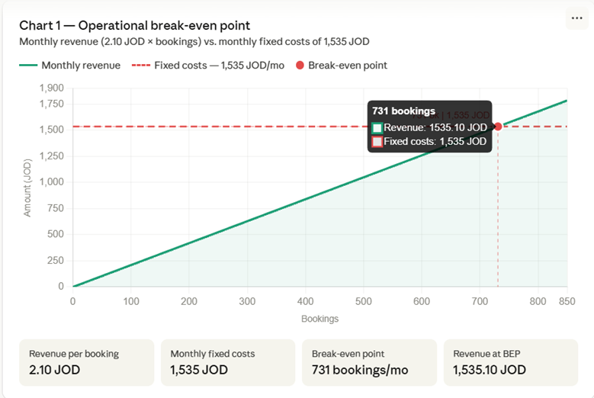
This graph presents the operational breakeven point. The horizontal axis shows the number of monthly bookings, while the vertical axis represents the amount of money in JOD. The green line shows the Maqar’s monthly revenue, that calculated as:
Monthly revenue = 2.10 * number of bookings
The red dashed horizontal line present the monthly operational cost, which is fixed a 1,535 JOD per month.
The breakeven point happen where the monthly revenue line interacts with the monthly cost line. According to the graph, this point is reached at 731 bookings per month, where Maqar’s revenue is approximately 1,535.10 JOD, which almost qual to the monthly operation cost of 1,535 JOD.
Which mean that Maqar should get about 731 bookings per month in order to fully cover its monthly operating costs. At that point the business is neither making a profit nor any loss. Any bookings above this level will start generating operating profit.
Overall interpretation
The graphical break-even analysis confirms the numerical results. It shows that Maqar becomes operationally sustainable at approximately 731 monthly bookings, at this point, Maqar’s monthly commission revenue becomes equal to its monthly operational costs, after this point, any additional successful bookings contribute to profit. This makes it easier to visually understand when the business moves from covering costs to generating profit, and it supports the financial feasibility of Maqar’s asset-light marketplace model.
When Maqar becomes Profitable (Profitability point)
The profitability point shows when Maqar starts generating profit after covering its costs. Based on the break even analysis, Maqar’s monthly operational cost is 1535 JOD, and Maqar earns 2.10 JOD from each successful booking which means that the business reach its operating breakeven point at
1535/2.10 = 730.95 bookings ≈731 bookings Since partial bookings are not possible
Maqar becomes operationally profitable after reaching around 731 bookings per month. At that point, Maqar’s monthly revenue is approximately
731 * 2.10 = 1535.10 JOD
This almost equal to the monthly operational cost of 1535 JOD meaning the business covered its monthly operating expenses. Any bookings above this level will start generating the profit for the business.
The monthly profit can be calculated using this formula:
Monthly profit = monthly revenue – monthly operational cost
Monthly profit = (number of bookings * 2.10 JOD) – 1535 JOD
As an example:
Monthly bookings | Monthly Revenue | Monthly Operational costs | Profit
500 bookings | 1,050 JOD | 1,535 JOD | -485 JOD
731 bookings | 1,535.10 JOD | 1,535 JOD | 0.10 JOD
800 bookings | 1,680 JOD | 1,535 JOD | 145 JOD
1,000 bookings | 2,100 JOD | 1,535 JOD | 565 JOD
1,500 bookings | 3,150 JOD | 1,535 JOD | 1615 JOD

This shows that Maqar is not profitable if it receives fewer than 731 bookings per month, as the commission income will not be enough to cover the monthly operational costs, but once Maqar reaches more than 731 bookings per month, the business begins to make profit, for example, at 1,000 bookings per month, Maqar would make an estimated monthly profit of 565 JOD.
Overall, Maqar becomes operationally profitable after approximately 731 bookings per month. The business becomes more financially attractive after this point because each additional booking adds 2.10 JOD in commission revenue, this supports Maqar's financial feasibility because the platform is asset-light, does not need to own or rent the physical rooms, and can generate profit once booking volume grows beyond the break-even level.

Project income statement
The project income statement provide a forecast of Maqar’s expected financial performance over the first 12 month after its launching. The goal of this projection is to test if Maqar’s business model can gradually become financially sustainable by comparing the expected monthly revenue, monthly operating costs, and profit or loss.
Since Maqar is a digital marketplace, the income statement is based in commission revenue rather than the full room rental price. The user pays the listed room price to the host, while Maqar earns a commission from each successful booking. So the projected revenue is calculated using the expected commission income per booking.
The projection is based in these assumption
Assumption | Value
Average room price per hour | 7 JOD | Average listed room rental price
Average duration for booking | 2 hours | Assumed average booking length
Average booking value | 14 JOD | 7JOD * 2 hours
Commission rate | 15% | Average between 10%-20%
Revenue per booking | 2.1 JOD | 14 * 15%
Monthly operational cost | 1,535 JOD

The revenue per booking is calculated as
7 JOD * 2 hours =14 JOD booking value
14 JOD * 15% = 2.10 JOD revenue per booking
The monthly revenue is calculated using this formula
Monthly REVENUE = Number of Bookings * 2.10 JOD
The monthly profit or loss in calculated using this formula
Monthly profit or loss = Monthly Revenue – Monthly Operational Cost
Maqar’s monthly operational cost is estimated at 1535 JOD per month, including hosting, database and storage, platform maintenance, domain and admin tools, ongoing marketing, founder outreach transport, founder compensation, and the contingency costs. These are the costs needed to keep the platform operating each month after launch.

Month | Projected Bookings | Projected Revenue | Monthly Operational Cost | Monthly Profit / Loss | Cumulative Profit / Loss
Month 1 | 400 | 840 JOD | 1,535 JOD | -695 JOD | -695 JOD
Month 2 | 500 | 1,050 JOD | 1,535 JOD | -485 JOD | -1,180 JOD
Month 3 | 650 | 1,365 JOD | 1,535 JOD | -170 JOD | -1,350 JOD
Month 4 | 750 | 1,575 JOD | 1,535 JOD | 40 JOD | -1,310 JOD
Month 5 | 850 | 1,785 JOD | 1,535 JOD | 250 JOD | -1,060 JOD
Month 6 | 950 | 1,995 JOD | 1,535 JOD | 460 JOD | -600 JOD
Month 7 | 1,050 | 2,205 JOD | 1,535 JOD | 670 JOD | 70 JOD
Month 8 | 1,150 | 2,415 JOD | 1,535 JOD | 880 JOD | 950 JOD
Month 9 | 1,250 | 2,625 JOD | 1,535 JOD | 1,090 JOD | 2,040 JOD
Month 10 | 1,350 | 2,835 JOD | 1,535 JOD | 1,300 JOD | 3,340 JOD
Month 11 | 1,450 | 3,045 JOD | 1,535 JOD | 1,510 JOD | 4,850 JOD
Month 12 | 1,550 | 3,255 JOD | 1,535 JOD | 1,720 JOD | 6,570 JOD
Total Year 1 | 11,900 | 24,990 JOD | 18,420 JOD | 6,570 JOD | 6,570 JOD
As Maqar is a new startup, the projected income statement assumes gradual growth in bookings during the first year. In the first months, the bookings activity is expected to be fewer, because the platform is still building awareness, onboarding hosts, and gaining user trust. Also as the marketing, university outreach, host partnerships, and user adoption increase, the number of bookings are expected to grow over time.

The projected income statement clear that Maqar is expected to operate at a loss during the first phase after its launch. This is normal for new digital marketplace as the platform needs some time to attract users, on board hosts, build trust and increase the booking activity. During these early months, the number of bookings is still below the operating break even point of approximately 731 bookings.
in the first month in the second quarter of the first year, the business is projected to pass the monthly operating breakeven point by reaching 750 bookings, at that point, the projected monthly revenue is
750 * 2.10 = 1575 JOD
After subtracting the monthly operational cost of 1535 JOD Maqar makes a small profit of
1575-1535 = 40JOD
From that point onward, the business becomes operationally profitable as the projected monthly bookings are above the breakeven level. As the bookings continue to increase, monthly profit also increases.
By the end of the first year, the business is projected to generate 24,990 JOD in commission revenue. The Total operational costs for the year are projected to be 18,420 JOD, resulting in an estimated operating profit of 6,570 JOD.
This project income statement shows that Maqar has a realistic path toward financial sustainability. Its right that the business may face losses in early months, the revenue is expected to grow as user adoption and host partnerships increase, and since Maqar is an asset light marketplace and doesn’t need to own or rent rooms, higher booking volume can increase the profitability while monthly operational costs remain relatively stable.
Note:
The startup cost recovery had not been included in the income statement above, to be calculated we subtract the startup cost from the total profit in the end of the year.
6,570- 3,250 = 3,320 JOD.

Financial Viability Evaluation
The financial viability evaluation shows whether Maqar is financially feasible, sustainable and capable of growing after launch, based on the projected income statement, the business is expected to generate 24,990 JOD in commission revenue during the first year, while the total monthly operational costs for the year are expected to be 18,420 JOD. This results in an estimated annual operating profit of 6,570 JOD before considering startup cost recovery.

1. The overall financial feasibility
Maqar shows financial feasibility as the business becomes operationally profitable after passing the monthly operating breakeven point of 731 bookings per month. In the projected income statement, the business is expected to pass this point in the 4th month of the year, when the projected number of bookings reaches 750 bookings.
At the 4th month:
750 * 2.10= 1575 JOD
After subtracting the monthly operational cost
1575 – 1535 = 40 JOD
Which means that Maqar starts making monthly operating profit from month 4 onward. The first three months show losses as the platform will be in its building awareness phase, onboarding hosts, and increasing the user adoption. But after that month, the monthly profit increases as the bookings grows.
By the end of the year, Maqar is projected to make
24,990 – 18, 420 = 6,570 JOD operating profit
Which shows that the business can cover its operating costs and generate profit within the first year if the projected booking growth is achieved.

2. profit margin
profit margin measures how much profit will the business keeps from its revenue after covering the operational costs
profit margin = Annual profit / Annual revenue * 100
using the projected figures:
profit margin = 6,570 / 24,990 * 100
= 26.3%
This means, for every 1 JOD Maqar earns in commission revenue, around 0.263 JOD remains as operating profit after covering the operational costs. A profit margin of 26.3% is positive for a digital marketplace as Maqar doesn’t own or rent rooms, that keeps fixed costs lower comparing to a physical workspace business.

3. Return on Investment (ROI)
ROI measures how much return the business is expected to generate compared to the initial investment.
The startup budget is 3,250JOD
Using the annual operating profit:
ROI = Annual Operating Profit / startup Investment * 100
Cash startup ROI
6,570 / 3,250 * 100 = 202.2%

But since the startup costs are not included inside the monthly income statement, its also useful to show that the remaining profit after recovering the full startup value:
6,570 – 3,250 = 3,320 JOD
This means that after covering both the yearly operational costs and the full startup value, Maqar can still end the first year with around 3,320 JOD in remaining profit.

4. Sustainability
Maqar’s financial model is sustainable as its based on the asset light marketplace structure. The business doesn’t need to buy, rent, or maintain physical rooms. Instead of that, it connects the users which existing spaces owned by hosts and earns a commission from successful bookings.
This reduces the financial pressure because Maqar’s main costs are related to platform operation, marketing, support, and the team compensation. As the number of bookings increases, the revenue frows while many monthly costs remain relatively stable. This means that after passing the breakeven point, any additional bookings can improve the profitability.
As an example, at 1000 bookings per month, Maqar would generate
1000 * 2.10 = 2,100 JOD
After the subtracting monthly operational costs
2,100 – 1,535 = 565 JOD monthly profit
This shows that Maqar can remain sustainable if booking volume stays above the operating breakeven point of 731 bookings per month.

5. Growth Potential
Maqar also has growth potential because the business can expand without the need to own physical spaces. Growth can come from increasing the number of hosts, increasing the number of bookers, and maintaining the bookers, the report already identifies strong demand from students, freelancers, remote workers, startup and the SMEs, especially in Amman’s high demand areas like khalda, Abdali, king Hussein business park, University of Jordan area, and Dapouq. Also some hosts may fully rely on our platform rather their own method in reservation like companio, which will give us the ability to receive more bookings.
In the future Maqar can also improve the revenue by adding extra revenue streams such as featured listings, premium booking features, and promotional partnerships. These additional revenue streams can increase the income without changing the core commission based model.

6. Limitations
Maqar’s financial projections show that Maqar has strong potential but there are some limitations that must be considered, first the project number of bookings is based on expected growth so actual results could be lower if user adoption is slower than expected, since Maqar is a new platform it might take more time to build trust with students, freelancers, remote workers and hosts.
Second, the monthly operational cost is estimated to be 1,535 JOD, but this cost might increase as the platform grows, for example marketing costs, customer support, technical maintenance, hosting and future payment gateways will increase if the number of users and hosts grow faster than expected.
Third, the project income statement doesn’t include tax, unexpected legal costs or major technical upgrades, these costs could reduce the final profit if they appear during actual operations.
Lastly, Maqar’s sustainability depends on keeping both sides of the marketplace active, as the platform needs enough users to make bookings and enough hosts to provide available rooms, if there sides grows slower, the projected revenue and profit might not be achieved within the first year.
In conclusion, the financial viability evaluation shows that Maqar can become profitable the results should be treated as realistic projections instead of guaranteed outcomes, and the business will need strong marketing, host onboarding, user trust and cost control to achieve the projected financial performance.

In conclusion, Maqar's financial evaluation shows that the business is operationally profitable after reaching 731 bookings per month. Despite the limitations such as variable adoption rates and potential cost increases, the projected profit margin of 26.3% and strong ROI of 202.2% demonstrate financial feasibility. Maqar's asset-light, commission-based marketplace model ensures sustainability, scalability, and growth potential, with the ability to expand revenue through increased bookings and additional services, making the platform a viable and promising venture.

22. Business model canvas
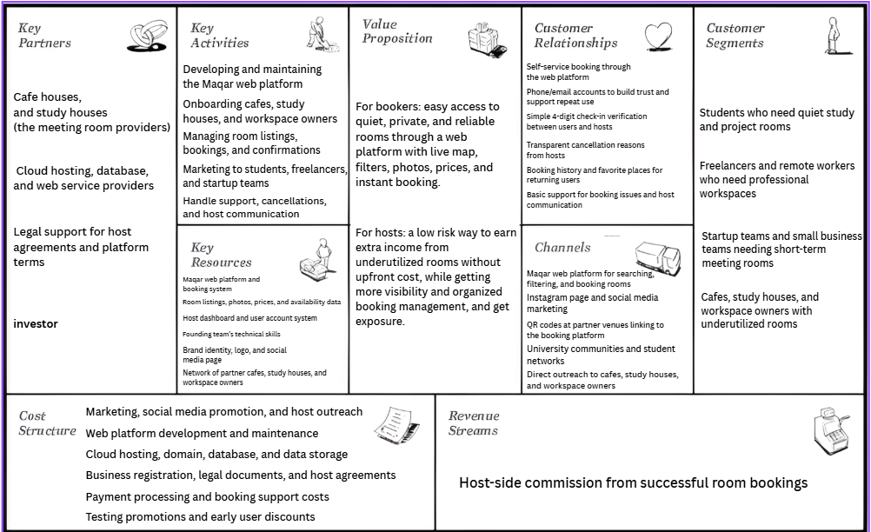

Component of each business model canvas:

Key Partners
The key partners of Maqar are the external parties, which help the business operates without the need of owning physical rooms, the main partners are cafe houses, study houses, and the workspace owners, as they provide the meeting rooms listed on the platform, cloud hosting, database, and web service providers are also important as Maqar depends on the digital platform for managing the listings, bookings, and the user accounts, the legal support is needed to prepare the host agreements, platform terms, cancellation rules, and the basic business documentation, the investors are also important partners as they provide the financial support for Maqar’s startup budget, which help the team to cover the early launch costs like the platform development, hosting, legal setup, marketing, testing, and the host onboarding

Key Activities
The key activities of Maqar are the main tasks that are needed for keeping the business running, These include the developing and maintaining of the web platform, the onboarding cafes and study houses, managing the room listings bookings and confirmations, and the marketing for the platform to students, freelancers, and the startup teams, Maqar also needs to handle the support, cancellations, and host communication for making sure both users and room providers trust the service.

Key Resources
Maqar’s key resources are the assets that are needed to deliver the service, the most important resource is the Maqar web platform and the booking system, as the business is based on the online room discovery and booking, the other important resources is including the room listings, photos, prices, availability data, the host dashboard, and the user account system, the founders team’s technical skills are also key resources as they allow Maqar to build and improve its platform at a the lower cost, the brand identity, logo, social media page, and the partner network also support trust and growth.

Value Proposition
Maqar offers the value for both sides of the marketplace, For the bookers, Maqar provide easy access for quiet, private, and reliable rooms through a web platform with a live map, filters, photos, prices, and instant booking, This reduce the time and effort that is wasted searching manually for suitable spaces, for the hosts, Maqar provides low risk way for earning extra income from the underutilized rooms without upfront cost, while also giving them more visibility and organized booking management, and offer an exposure.

Customer Relationships
Maqar’s customer relationships are mostly based on the self service, trust, and the transparency, the users can search and book the rooms through the web platform without the needing for calling or visit the different locations first, phone and email accounts help building the trust and the support for repeat use, the 4 digit check in verification creates simple connection between the user and the hosts when the user arrives, the Transparent cancellation reasons, booking history, favorite places, and basic support also help maintain a better relationship with returning the users and host partners.

Channels
Maqar reaches and serves the customers through several channels, the main channel is the Maqar web platform, where the users search, filter, and book rooms, instagram and the social media marketing are used for creating awareness and attract students, freelancers, and startup teams, the QR codes at partner venues can also direct users to the booking platform, university communities and student networks help Maqar reach student users, while the direct outreach to cafes, study houses, and workspace owners helps with attracting room providers.

Customer Segments
Maqar serves the two main sides, bookers and hosts,
the bookers side include the students who need quiet study and project rooms, freelancers and remote workers who need professional workspaces, and startup teams or small business teams who need a short term meeting rooms, The host side includes cafes, study houses, and workspace owners with an underutilized rooms, These groups are suitable for Maqar as they either need reliable temporary spaces or have unused spaces that can generate the extra income.

Cost Structure
Maqar’s cost structure is mainly connected for running a digital marketplace, the main costs including the web platform development and maintenance, the cloud hosting, the domain, the database, and the data storage, the Marketing, social media promotion, and the host outreach are also important costs as Maqar needs to attract both users and room providers, the other costs include business registration, legal documents, host agreements, payment processing, booking support, testing promotions, and the early user discounts.

Revenue Streams
Maqar’s main revenue stream is host side commission from the successful room bookings, This means that users pay the listed room price, while Maqar take the percentage from the host after the booking is completed, this keeps the platform attractive for users as they don’t pay extra platform fees, in the future, Maqar can add more revenue streams such as featured listings, premium booking features, and the promotional partnerships, but the core revenue stream remains the commission from the successful bookings.

The interconnection between the BMC components and how it supports the feasibility and coherence:
The components of Maqar’s Business Model Canvas are strongly connected as the business operates as two sided digital marketplace, such like a bridge. The key partners, especially cafes, study houses, and the workspace owners, provide the supply side of the business by offering the underutilizeed rooms, these rooms become part of Maqar’s key resources through the room listings, photos, prices, and the availability data, without these partners, Maqar would not have spaces tooffer, and without the web platform, these spaces wouldn’t be easy for the users to find and book.
The value proposition connect directly for the both of customer segments, the Students, freelancers, remote workers, startup teams, and small business teams need quiet, private, and reliable rooms, while the hosts need a way for earning extra income from the unused spaces, Maqar connects these two needs by giving the users easier booking experience and giving the hosts more visibility and organized booking management, this makess the model solid as the problem, customers, solution, and partners all support each other.
the key activities support the value proposition, Developing and maintaining the web platform allow users to search, filter, and book rooms easily, onboarding hosts make sure that there are enough rooms available on the platform, the managing bookings, confirmations, cancellations, and support helps with building the trust between users and hosts, These activities make the service practical and feasible as they shows how Maqar will actually deliver its promised value in the daily operations.
the customer relationships and the channels also work together, The web platform, Instagram, QR codes, university networks, and the direct host outreach helps Maqar reaching both sides of the market, at the same time, the self service booking, phone/email accounts, the 4 digit check in verification, booking history, and the transparent cancellation reasons are helping with maintaining the trust and encourage repeat use, that supports the feasibility because Maqar can reach the users and hosts using the low cost digital and the community based channels instead of the expensive physical branches.
the cost structure and the revenue streams show the financial coherence of the model, since Maqar doesn’t buy or rent the rooms, the biggest costs are related to the platform development, hosting, maintenance, marketing, legal support, and the booking operations, these costs match nature of the business as an asset light digital marketplace, the main revenue stream, host side commission from the successful bookings, is also directly connected to the platform’s main activity, Maqar only earns when successful booking happen, that keeps the model attractive for the users while making the hosts pay only when they receive the value.
overall, the business model canvas shows that Maqar is feasible as it uses existing rooms instead of owning a physical spaces, reach the customers through low cost digital and the community based channels, and focuses its costs mainly on the platform development, hosting, marketing, legal support, and the booking operations, Its also coherent as every component support the same central idea connecting the people who need quiet workspaces with the venues which have underutilized rooms, the revenue model also supports this structure as Maqar earns mainly through host side commissions from the successful bookings which mean the platform generates income only when its successfully create a value for both the booker and the host.

23.Business Model Evaluation

1. Key Partners
The maqar’s key partners are one of the strongest parts of the business model as the platform depends on external room providers instead of owning the physical spaces, the partnering with the cafes, study houses, and the workspace owners make the business more feasible and reduces startup costs, this supports the asset light model as Maqar can grow by adding more partners rather than renting or buying rooms, but this component also has a risk as Maqar depends heavily on the quality, availability, and the cooperation of these partners, if hosts don’t update the availability, reject bookings frequently, or provide the poor room conditions, the user experience will be affected, therefore, Maqar needs a clear host agreements, onboarding rules, and the quality control standards.

2. Key Activities
The key activities are realistic because they focus on what Maqar must actually do to operate: maintain the platform, onboard hosts, manage listings and bookings, market the service, and handle support. These activities directly support the value proposition because users need a smooth booking process and hosts need organized booking management. However, the weakness is that some activities may become difficult as the platform grows. For example, customer support, host communication, and cancellation handling may require more time and staff if booking volume increases. Maqar should prepare simple internal processes and automation tools to reduce operational pressure.

3. Key Resources
Maqar’s key resources are suitable for the digital marketplace, The web platform, booking system, host dashboard, room listings, user accounts, and the founders team skills are all essential to the business, a one strength of this component is that Maqar doesn’t rely on expensive physical assets, making the model more affordable and scalable,but the platform itself becomes a critical resource, that means that any technical failure, security issue, or poor user experience could damage the trust, Since Maqar handles the user data, booking records, and payment related information, the platform security and maintenance must remain a priority.

4. Value Proposition
The value proposition is clear as Maqar solves a real problem for the both sides of the marketplace, for the bookers, it reduce the time and uncertainty involved in finding a quiet, private, and reliable rooms, For the hosts, it creates low risk way to earn extra income from underutilized spaces, remove the effort of the manual work, and apply exposure, which make the value proposition strong and balanced, but the challenge is that users might compare Maqar with free alternatives such as regular cafes or manual booking through phone calls, so To stay attractive, Maqar must make the value obvious through convenience, confirmed availability, clear prices, real photos, and reliable room quality.
5. Customer Relationships
The customer relationship model is practical as it is mainly self service, supported by trust building features such as phone/email accounts, 4 digit check in verifications, booking history, favorite places, and the transparent cancellation reasons, that keeps the service simple and reduces the need of heavy manual support, but because Maqar connects two sides, users and hosts, relationship management can become sensitive, as If a booking is cancelled, delayed, or different from the listing, Maqar might need to act as a mediator, so for clear support rules and cancellation policies are important to maintain trust.

6. Channels
The channels are suitable for Maqar’s early stage as they rely on the low cost and direct methods such as web platform, Instagram, social media, QR codes at partner venues, university networks, and the direct host outreach, those channels fits the target audience, especially the students, freelancers, and startup teams, the strength is Maqar doesn’t need expensive physical branches or large advertising campaigns at the beginning, but relying too much on organic social media and university networks might limit the growth, As the platform grows, Maqar may need stronger digital marketing, partnerships, and referral campaigns for reaching more users and hosts.

7. Customer Segments
The customer segments are well defined as Maqar serves both the demand side users and the supply side hosts, the students, freelancers, remote workers, startup teams, and the SMEs have a clear need for flexible meeting rooms, while the cafes, study houses, and workspace owners might benefit from monetizing the underused spaces, These two sided structure gives Maqar a strong market logic, but serving different segments also creates complexity because students may be price sensitive, freelancers may care about the reliability and Wi-Fi, and the SMEs may expect more professional standards, Maqar should make sure its listings and pricing options match the different needs for each segment.
8. Cost Structure
Maqar’s cost structure is realistic and relatively lean as the main costs are connected to the platform development, hosting, maintenance, security, marketing, legal support, payment processing, and the booking support, the main advantage is Maqar avoid high fixed costs of renting or owning the rooms, This enhance feasibility and reduces the financial risk, but some costs may increase as the platform grows, especially customer support, data storage, marketing, and the platform security, Maqar must monitor these costs carefully to make sure growth doesn’t reduce the profitability.

9. Revenue Streams
The main revenue stream, the host side commission from the successful bookings, fits the business model as Maqar earn money only when it creates value through the completed bookings, which keeps the platform attractive for users as they don’t pay extra platform fees, It also makes the model fair for the hosts as they only pay when they receive a booking, but, depending mainly on the commission can be risky as revenue depends on booking volume, If early adoption is slow, income may not cover operating costs quickly, so in future, Maqar could strengthen financial sustainability by adding the featured listings, the promotional partnerships, or even premium booking features after the platform builds enough users and hosts.
Overall, Maqar’s Business Model Canvas is coherent as the components supports each other, the partners provides rooms, the platform makes them discoverable, the users create a demand, the host provide supply, and the commission model connect the revenue directly to the successful bookings, The business is feasible as it uses assetlight model, but its success depends on building the trust, keeping room quality consistent, attracting enough hosts and users, and managing platform operations efficiently.

Specific Enhancements for improving the feasibility, desirability, and the viability

for improving feasibility, Maqar have to strengthen the host onboarding and quality control, This can be done by creating a clear host agreements, minimum room standards, updated availability rules, and a simple host training guide, Maqar must also prepare the basic internal processes for booking support, cancellation handling, and the host communication so the business can operate s smoothly because the number of users and hosts increases.
for improving desirability, Maqar must make the user experience more trustworthy and attractive, this can be done by adding verified room photos, clear room features, user reviews, ratings, and more transparent cancellation rules, the Student discounts and location based promotions can also make the platform more appealing for students, freelancers, and the startup teams whom are price sensitive but still need quiet and reliable workspaces.
for improving the viability, Maqar must protects its revenue model and reduces the financial risk, the main revenue stream must remain the host side commission from the successful bookings, but after the platform grows, Maqar can add featured listings, promotional partnerships, and premium booking features, Maqar must also monitor operating costs such as hosting, maintenance, marketing, support, and payment processing for ensuring that the business can become financially sustainable because booking volume increases.

24. Final Prototype Development

1. Final Prototype Presentation and Core Functionalities:

The final version of the Maqar platform represents a highly optimized marketplace that bridges the operational divide between independent professionals and vacant commercial workspace assets in Amman. To ensure maximum grading completeness and technical transparency for the evaluation grade the final validated prototype code is officially submitted alongside this report as a fully functional HTML and component package instead of putting in pictures as this final iteration doesn’t vary very much from the last one and only fixes some small things. Tracing the software journey from its zero baseline reveals a product that has matured from a simple theoretical booking concept into a highly responsive web application. the completed prototype organizes its functionality across three core operational pillars: an advanced map first discovery portal for bookers with the ability to view and book rooms related to their actual real time availability times and a secure profile and data tracking layer for users and an automated management console for workspace hosts

The user side discovery interface allows students, remote workers or freelancers and startup teams to immediately view workspace opportunities across high density target neighborhoods such as Khalda, Abdali, Dabouq, the University of Jordan and the King Hussein Business Park. the platform renders an interactive map displaying live room locations bypassing the traditional friction of physical web searches or unanswered phone calls. Users can deploy filters to isolate venues by capacity requirements and technical assets,such as matching rooms with high speed Wi-Fi, whiteboards or presentation monitors. Once a room is selected and booked the platform guides the professional through a user dashboard. This authenticated account environment features real time tracking including a Booking history tab with dynamic booking status tags alongside a favorite Places shortcut that lets professionals verify daily vacancy schedules and rebook their top performing focus hubs in seconds

A newly integrated feature for the user dashboard that was introduced in this iteration is the real time booking countdown timer. once a host approves a reservation slot this countdown clock displays on the user main control screen providing a visual tracking window of how much time remains for their active workspace booking. To prevent sudden operational interruptions the user interface features an im Running late button clicking this button pushes an automated notification directly to the host administration view preserving communication without forcing the user to make external phone calls or send manual WhatsApp text messages

On the supply side the host dashboard equips local space providers with an automated management tools replacing outdated pen an paper logs with dynamic 30 minute increment reservation chains. This view provides venue owners with clear charts tracking live occupancy percentages and daily revenue generation metrics. To maintain operational clarity and eliminate systemic booking confusion the host management interface features a mandatory cancellation validation field. If a host is forced to deny or cancel an incoming room request due to internal scheduling changes the system blocks the action until they input a specific operational reason. This input triggers a visible red notification banner on the bookers screen preserving complete system transparency

The final checkout and transaction of the prototype features a newly hybrid split payment designed to protect both the user upfront trust and the host venue capacity. Influenced by Companio owner notes the system prompts the user to pay exactly half of the booking fee online as a secure down payment via CliQ so The booker uploads a quick transaction screenshot to clear this digital ate, while the remaining 50% balance is settled physically invenue when arrived

Once the down payment is logged the prototype generates a 4 character check in code directly on the booker screen and Upon arrival at the space the user displays or states this code to the venue receptionist. The receptionist keys this 4 digit into the dedicated guest
Check in validation field on the host dashboard which matches the code against the background store and updates the calendar row to completed booking and opens the workspace loop without requiring any specialized scanning hardware

2. Evolution and Iterative Refinement Timeline

The state of the final Maqar prototype is the result of a highly solid iterative software development lifecycle that continuously refined its technical logic based on cross Stakeholder feedback so The initial concept phase or Version , was restricted by theoretical security assumptions. In our original design we believed that maximizing user and host safety required a heavy identity verification gateway. our v0 checkout completely blocked users from viewing booking availability or accessing payment screens until they uploaded sensitive government documents. the early check in framework relied on QR code generation which theoretically provided secure entry tracking but introduced a real world operational barrier for local business owners

the first major change happened during iteration 1 which focused on optimizing the consumer onboarding funnel and establishing our core visual brand. usability data from target respondents showed friction about data privacy with users stating they would abandon the platform if forced to share government identification cards with an early stage application. in response our development removed the mandatory civil ID upload requirement out of the signup and checkout pathways we replaced it with a fast verified email and phone number account generation screen lowering the entry barrier while maintaining a secure and trackable user profile database

To protect the student validation features planned in part 1 we repurposed the university ID upload into a completely voluntary single click verification toggle inside the main user profile header. Regular professionals could book instantly without uploading documents while student users could choose to link their academic credentials to instantly unlock an optional discount badge. Iteration 1 also introduced the long term layout foundation for the application transitioning from text only wireframes to an integrated visual space featuring our official Maqar logo permanently anchored within a sticky top navigation header draped in a minimalist coffee shop inspired color scheme

Iteration 2 shifted our focus to solving the operational overhead discovered during deep dive stakeholder interviews with local Amman venue managers. When testing the v0 QR code framework with the owner of Companio they highlighted that fast paced cafe environments and study lounges cannot handle the operational burden of adopting new hardware scanners or forcing baristas to open specialized scanning screens during peak rush hours. To resolve this supply side barrier we engineered the dynamic QR codes out we replaced them with our 4 digit verification code system which preserved entry security while requiring zero technology adoption or hardware overhead from the host venue reception staff

The final and most significant change was achieved by a full structural code refactoring and optimization phase (this final phase in part 3) while previous iterations were built using rapid front end generations inside Cursor AI we migrated the entire codebase to Claude Code for our final production build. This allowed us to clean up the code optimize layout response times and achieve a professional user friendly user interface polish. Under Claude Codes refined engineering logic we implemented our final two major features: the real time active dashboard countdown clock and the requested 50/50 split payment workflow

3. Realization of Problem Resolution and Addressing User Needs
The architectural and functional design of the final Maqar prototype serves as a direct data backed resolution to the workspace gaps identified in our primary market research. Our initial survey of 132 real Amman respondents established that 70.2% of university students and remote professionals face a recurring monthly struggle to secure an appropriate focus space and 49.6%identify ambient noise as their greatest frustration. Maqar map discovery interface addresses this visibility gap by replacing the traditional exhausting routine of driving around high density neighborhoods looking for a desk. By displaying verified quiet venues near the user in real time and allowing them to filter specifically for technical assets like whiteboards or privacy monitors the prototype guarantees an optimized workspace environment before the professional ever leaves their home

the integration of the 30 minute incremental booking system matches the budget constraints and workflow habits of our target demographic. Traditional commercial co working spaces or offices force users into purchasing rigid expensive monthly or full day passes which are financially inaccessible for most university students or independent freelancers where Maqar resolves this friction by allowing users to purchase only the exact time increments they require to run a project sprint, complete a study session or conduct a online interview

This flexibility is matched by the newly added countdown timer on the user dashboard. By giving remote workers a clear of their remaining window and embedding a one click im late notification link the platform removes the communication gaps that frequently lead to lost reservations and host side frustration.\

On the supply side the platform addresses the missed revenue and underutilized real estate realities that suffers local small businesses across Amman. Commercial hosts pay high monthly rents for prime real estate in areas like Abdali and the King Hussein Business Park yet their private meeting rooms and boardrooms frequently sit empty for hours out of the day Maqar provides these hosts with a zero risk asset light revenue model allowing them to list these empty hours to an active community of paying professionals

The real world effectiveness of this solution was confirmed during our on site validation sessions. The management at Almond expressed interest in joining our initial program while the owner of Companio confirmed that our human centered 4 digit check in code and automated cancellation transparency solved their primary operational overhead concerns In fact the owner of Companio stated they are fully willing to convert their venue entire manual booking operation to Maqar digital marketplace. This validation proves that our final prototype design has moved beyond a course for university delivering a tool that answers the economic and technical needs of Amman collaborative workspace economy

26. Reflection on Pitching Skills:

1. Application of Presentation and Persuasion Skills:
The persuasive power of our pitch was built by the structural design and thematic continuity and narrative sequence used into our presentation slides and presented script. Recognizing that a successful presentation requires moving an audience from emotional alignment to logical conviction. we designed our script to open with a personal narrative rather than abstract corporate statistics or a story about a non existent person. The script was written to place the listener directly inside a high tension scenario tracking the exact psychological anxiety of watching the clock count down to a career defining online job interview while being physically turned away from overcrowded study houses and ignored by unanswered phone calls. By articulating the fear of losing a job and the risk of leaving a bad first impression due to the loudness and lateness of a coffee shop the script established an authentic humanized problem statement. This narrative hook was followed by a slide containing objective primary data transitioning from a personal story into a verified market crisis where local professionals face an identical struggle and they identify noise as their main productivity barrier

To build immediate credibility and authority without overcrowding our spoken remarks our presentation slides were designed to act as clean high level visual rather than dense blocks of text. We chose a specific minimalist background paired with blue navy titles and warm coffee brown subheaders to create a industry appropriate aesthetic that reflected our workspace domain and colors of our website. By placing our official Maqar theme into the every single slide the visual layout communicated professional brand and operational legitimacy from the first second. the script was structured as a tightly synchronized dialogue that distributed narrative responsibilities based on content type where one speaker focused on delivering the emotional storytelling, user centric advantages and customer engagement frameworks while the other speaker handled the precise technical engineering parameters and macro to micro market calculations and unit economics. This strategic script division ensured that our transitions felt natural and purposeful projecting the image of a highly organized, balanced and capable founding team

The composition of our slides also enhanced this persuasion by respecting the audience visual attention and preventing cognitive overload. Instead of cluttering the slides with paragraphs of code or operational details we used structured comparison grids and bold data percentages and clean icons to summarize our main ideas. This design choice forced the judging panel to look at our core metrics on the screen while relying entirely on our spoken script to fill in the deep qualitative context. for instance when introducing our prototype core features the slide highlighted simple high impact categories like discovery, host tools and user synchronization while the script explained how these interfaces worked together to eliminate manual friction and streamline user workflows. By weaving this level of intentionality through our slides and script we maintained full audience engagement across all sections of the presentation

2. Effectiveness of Investor communication:

ommunicating a shared economy business model to potential investors requires shifting the conversation from a creative concept to a de risked predictable and highly scalable financial asset. Our script and slides achieved high communication effectiveness by answering the operational concerns, technology adoption challenges and financial parameters that professional investors look for in an early stage startup. we used our script logic to diffuse the major risk of real estate overhead by saying Maqar is a purely asset lightplatform. By dedicating specific slide space to demonstrate that Maqar owns zero physical properties and carries absolutely zero lease liabilities so the script communicated to investors that our expansion model has a near zero cost of replication and scaling purely by unlocking pre existing underutilized corporate boardrooms during their empty hours

The validation win of our investor communication was our ability to present real world commercial situations and numbers on our slides rather than hypothetical assumptions. The script detailed our prototype walkthrough with the management of Companio coffee house and highlighting their confirmation that they are fully willing to convert their venue entire manual booking operation to Maqars digital system. this with the documented interest from local brands like Almond this slide served as proof of concept demonstrating to investors that we have already unlocked product market fit on the supply side. we also addressed investor fears about technology adoption barriers by highlighting our user driven code modifications so we explained our transition away from QR codes which would force busy receptionists to manage external hardware scanners and replacing them with a 4 digit verification code that matches effortlessly on the host dashboard. This explanation proved to investors that our development team prioritizes human centered low friction software design optimized for fast paced commercial settings

To capture the interest of the panel, our customer engagement and business model slides presented precision in our economics and market scaling strategies. the customer engagement slide detailed a practical multi channel strategy utilizing peer to peer campus ambassador networks and word of mouth marketing, alongside physical QR displays at partner venues to capture walk in professionals which proved to investors that we have an organic low cost path to market. This was backed up by our business model slide which mapped our success based 10% to 20% backend commission structure against a highly conservative user booking baseline. By calculating an annual Long Term Value (LTV) of 105 JOD per active user team against an acquisition cost (CAC) of under 2 JOD we demonstrated clear highly profitable margins. We closed our investor communication by presenting a completely transparent pre-launch cash budget on our final slides showing exactly how the requested capital would be spent

Appendix:
Survey link: https://docs.google.com/forms/d/e/1FAIpQLSfBDZkVBiNbw00-ecqb3REGhP7zLjV4rfDQSJw4OJHkqce1HA/viewform?usp=header
Interview script:
Hi, I'm part of a team of Computer Science and Cybersecurity students from HTU. We are currently developing Maqar, a platform that helps Amman-based businesses like yours earn passive income by listing their underutilized meeting rooms for hourly rental and help them gain more publicity.
We know that professional space is expensive, and we’ve noticed many high-quality meeting rooms sit empty for parts of the day. We are building a Security-First system to bridge that gap. Could I borrow 3 minutes of your time to ask 3 quick questions to see if this could be a revenue-generator for your office?
Q1 (Validation): "On a typical weekday, roughly what percentage of the time does your meeting rooms or extra office sit empty?"
Q2 (Revenue): "If a platform handled the marketing and booking, would you be interested in a system that helps in making you money and help with your monthly rent by booking that space to verified professionals?"
Q3 (The Barrier): "What is your biggest concern about letting an outside professional use your meeting room for an hour? (e.g., Physical security, data privacy, or just the hassle of check-in?)"
Work division:
All: 1 & 2
saif: 8 & 10
Khaled: 3 & 4 & 8
Yousef: 9 & 6
tamer: 7 & 5

The first Iteration of the prototype:
https://core-objective-design--saif2005ib.replit.app

Initial design concept (mockup):
https://stitch.withgoogle.com/projects/6189171922624930973
The transition of the Maqar prototype across these two development phases reflects a shift from theoretical constraints to real world operational efficiency. By listening directly to the feedback of over 130 target users and local Amman workspace operators like Companio and Almond, our team evolved the platform from a tech heavy restrictive design into a human centered frictionless platform. These modifications balance user privacy and layout continuity on the demand side with fast checkins and transparency on the supply side proving that a secure platform can still feel incredibly welcoming and simple to use.



Iteration 1: enhancing the Booker Experience and lowering Friction:

- Privacy first account Creation: We completely removed the mandatory requirement for users to upload sensitive personal documents like Civil or University IDs just to view payment windows or complete a reservation. It was replaced with a clean, standard email and phone number account registration setup.

  - Justification: This resolves the Trust vs. Privacy discovered in our user research. Forcing users to hand over official government identification to a new platform created severe anxiety and checkout abandonment moving to a verified phone and email system retains security while significantly speeding up user onboarding.

- Repurposing the Student ID for financial incentives: Instead of discarding the student ID feature entirely we shifted it into a voluntary, single click validation button inside the active user dashboard that applies an instant discount across participating spaces.
  - Justification: This turns a restrictive operational barrier into a positive marketing reward. Regular professionals can now check out immediately without friction, while student demographics are actively incentivized to link their university credentials to unlock tailored savings.
- deploying the user dashboard infrastructure: We brought our out of scope backlog into our primary code building an workspace profile system featuring clear sections for booking history complete with past date logs, dynamic status colors, and favorite places .
  - Justification: This satisfies the strong demand for continuity voiced by remote workers and freelancers. Users can now bypass the main map view to track their business expenses, review past host parameters or re reserve their preferred focus rooms with a single click.
- Visual Brand and Identity Integration: We formally launched our visual presence by permanently adding our new Maqar Logo into the navigation header alongside our user approved, minimalist coffee themed color palette.
  - Justification: Shifting from an text only interface to an established visual layout instantly communicates professionalism and builds genuine platform legitimacy .

Iteration 2: Operational streamlining and the host bridge:

- 4-Digit check-In codes: We completely eliminated the QR code generation from the booking confirmation screens replacing it with a readable 4-character alphanumeric code
  - Justification: This addresses the critical operational friction point highlighted by the owner of Companio. Busy baristas and office managers do not want the physical or technical hassle of handling scanner hardware or opening dedicated apps during peak customer rush hours. a quick, code match is fast, flawless and requires zero technology adoption from the venue staffd.

- host arrival validation and log optimization: We introduced a guest checkIn validation block onto the primary host dashboard where space providers can instantly see the user’s arrival code to immediately verify, mark complete and clear the reservation slot.
  - Justification: This features a low effort system that automates scheduling confirmation for hosts, allowing them to optimize their room tracking and easily view their real time daily occupancy percentages and only allow in authenticated visitors.

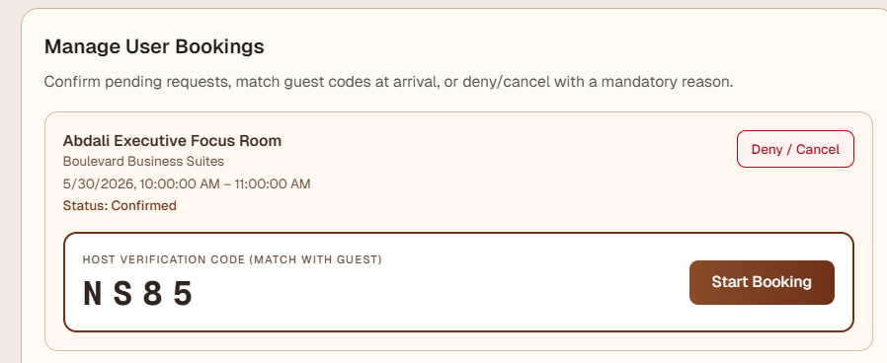

mandatory cancellation transparency: When a host needs to deny or cancel an incoming room request, the console now requires them to type out a mandatory operational reason which instantly displays as a highly visible red alert banner on the user's dashboard.
  - Justification: This eliminates confusion and builds an authentic ecosystem of trust. instead of facing an unexplained frustrating booking rejection users are given clear visibility into venue changes allowing them to look for an alternative space near them.

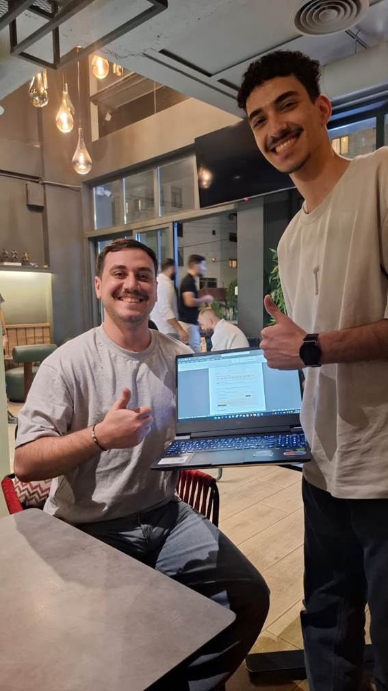

An image after the first iteration with the manager of Companio.
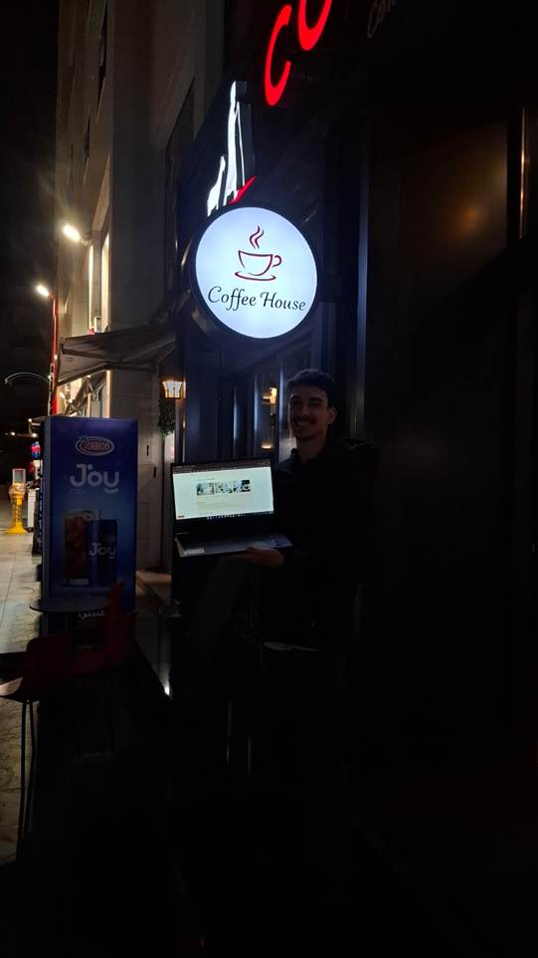

An image outside, after the second iteration with the owner of Companio.

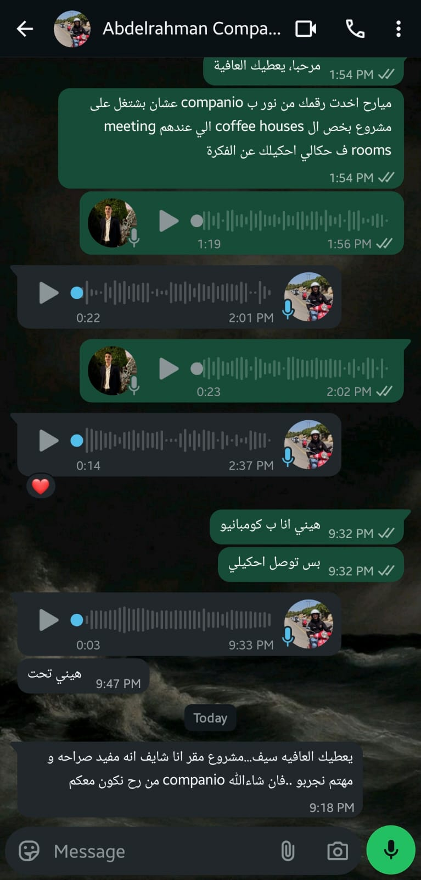
The validation from the owner of Companio showing interest in the project.

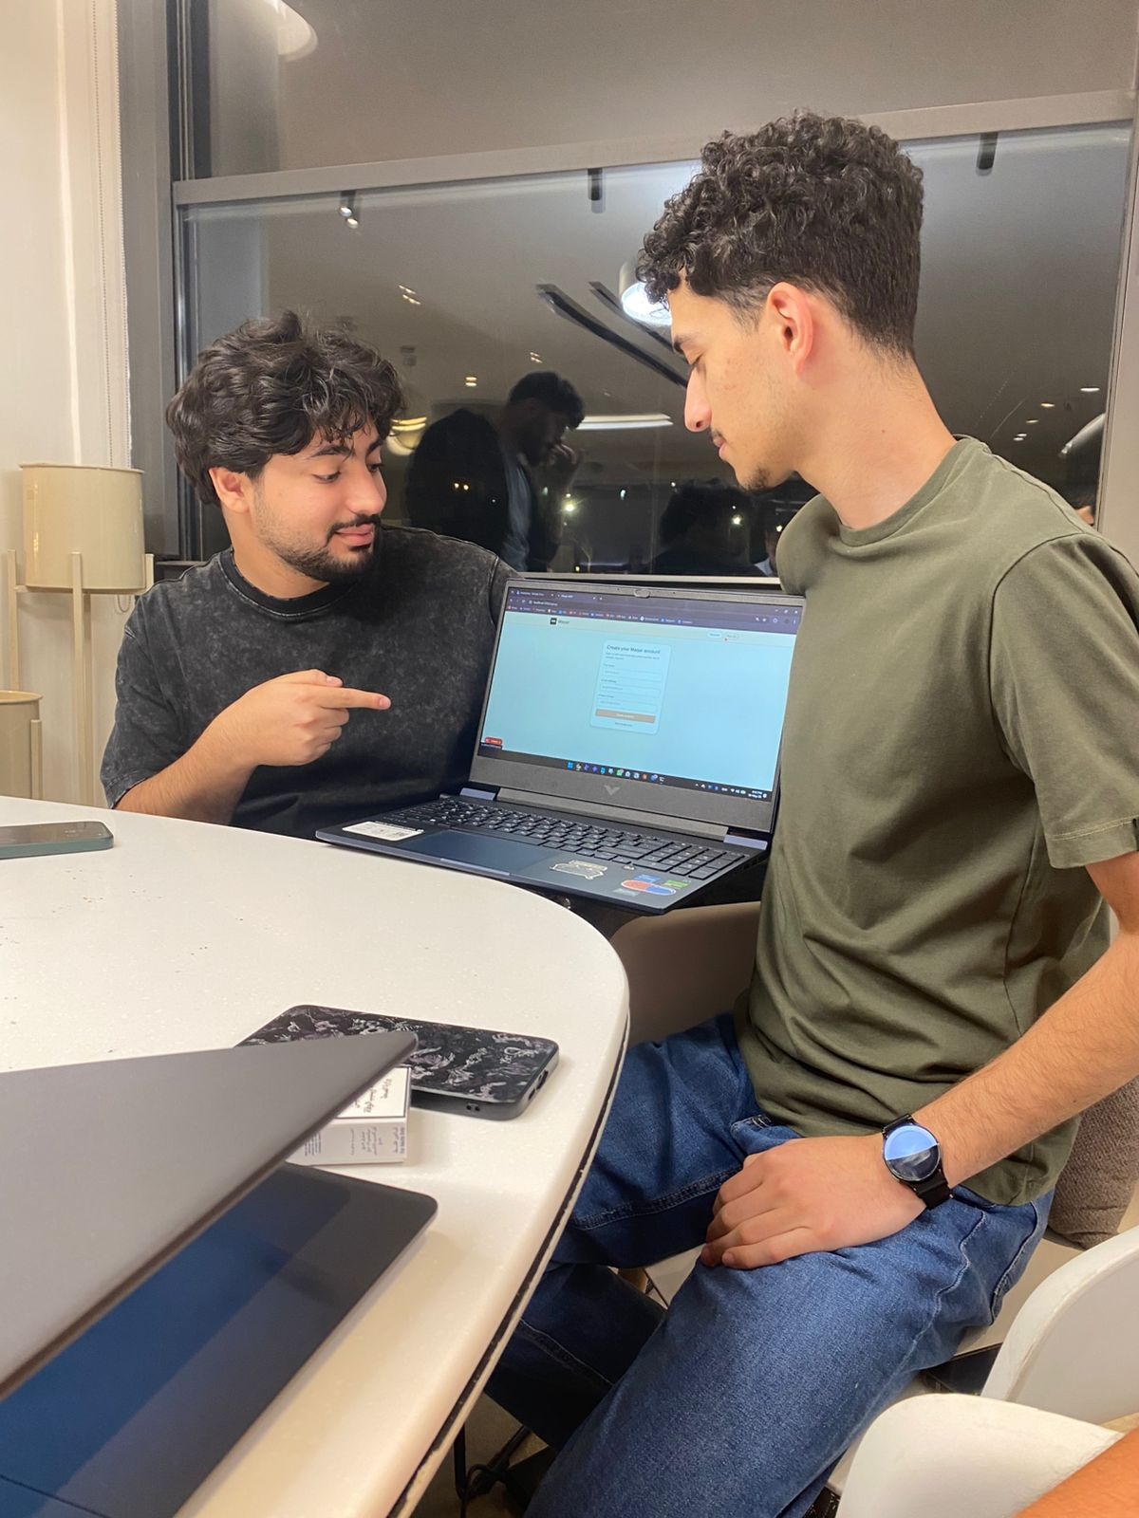

Iteration 1 with users, verifying the login page and additional features.

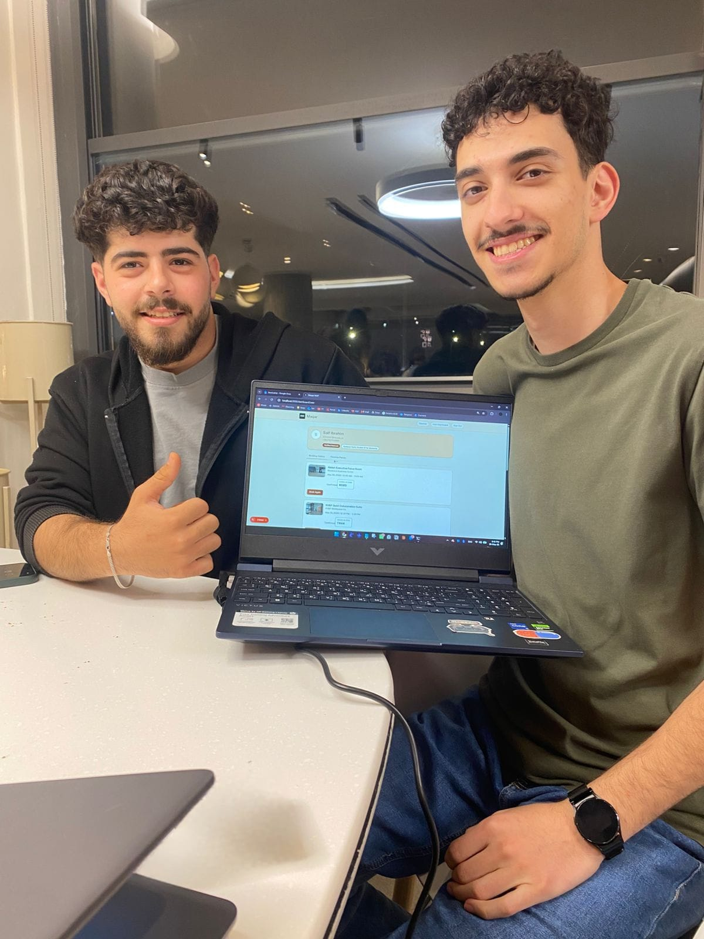
Iteration 2 with users, verifying the dashboard and additional features.

Saif: 11, 12 + prototype

Tamer: 13, 14 ,15

Yousef: 16, 17 ,18

Khaled: 19, 20 ,21

References & Digital Deliverables
Maqar Initial Design Concept (UI/UX Mockups): https://stitch.withgoogle.com/projects/6189171922624930973
Maqar User Feedback & Market Validation Survey Form: https://docs.google.com/forms/d/1AG0QaR3hk6I__p5kPWnrgtIT83PvGnQHozQYLTIbSXk/edit
According to the global study Shared Meeting Room Market, Global Outlook and Forecast 2026-2034, the international market for on-demand shared meeting spaces is valued at $3.50 Billion and is on track to grow to $5.84 Billion by 2034.
Industry guides like the Sunny Street Cafe Off-Peak Revenue Strategy Report highlight that empty tables and spaces directly destroy a local venue's weekly profit margins.
Department of Statistics Jordan. (2023). Jordan Statistical Yearbook 2023. Amman: Department of Statistics. http://dosweb.dos.gov.jo/
Global Entrepreneurship Monitor (GEM). (2022). Global Entrepreneurship Monitor Jordan National Report. London: GEM Consortium. https://www.gemconsortium.org/report
International Labour Organization (ILO). (2022). Employment and Labour Market Trends in Jordan. Geneva: ILO. https://www.ilo.org/resource/publications
International Telecommunication Union (ITU). (2023). Measuring Digital Development: ICT Development Index 2023. Geneva: ITU. https://www.itu.int/en/ITU-D/Statistics/Pages/publications/idi.aspx
Ministry of Digital Economy and Entrepreneurship. (2021). Jordan Digital Transformation Strategy 2021 to 2025. Amman: Government of Jordan. https://www.modee.gov.jo/EN/Pages/Strategies
https://www.jordannews.jo/Section-109/News/Higher-Education-Ministry-55-410-International-Students-from-119-Countries-Studying-in-Jordan-51395
Small Business & Micro-Enterprise Census (MSMEs):
https://www.giz.de/en/downloads/giz2023-en-jordan-financial-inclusion-study-2022.pdf
Digital Economy & Independent Freelancer Growth:
https://www.modee.gov.jo/ebv4.0/root_storage/en/eb_list_page/ytj_social_assessment_nov7.pdf
Department of Statistics Jordan 2023Jordan Statistical Yearbook . Amman: Department of Statistics
Global Entrepreneurship Monitor 2022 Global Entrepreneurship Monitor Jordan National Report . London : GEM Consortium
International Labour Organization 2022 Employment and Labour Market Trends in Jordan.Geneva: ILO .
International Telecommunication Union 2023 Measuring Digital Development . ICT Development Index . Geneva : ITU
Ministry of Digital Economy and Entrepreneurship 2021 Jordan Digital Transformation Strategy 2021 TO 2025 . Amman : Government of Jordan
OECD 2020 SME Policy Index : Middle East and North Africa 2020. Assessing the Implementation of the Small Business Act for Europe . Paris : OECD Publishing
World Bank 2021 Digital Adoption Index 2021 . Jordan Country Profile , Washington, DC: World Bank
World Bank 2022 Remote Work and Digital Jobs in the Middle East and North Africa. Washington , DC World Bank.
World Bank 2023 Jordan Economic Monitor Strengthening Resilience in a Challenging Environment . Washington, DC : World Bank

